**NAME: BINYANYA DEBORAH NYATICHI**

**CS NO: ADC-CSS02-25051**.

**DESCRIPTION: Week 3 Assignment 5**

**ASSIGNMENT: Lab on Describe the capabilities of Microsoft Security Solutions**

**DATE: 02/05/2025**

# INTRODUCTION

This week, I will be working on a series of labs designed to help me explore the capabilities of Microsoft Security Solutions. I will begin by setting up a Microsoft 365 tenant, which will provide the foundation for testing and configuring various security features. I will then explore tools such as Azure Network Security Groups (NSGs), Microsoft Defender for Cloud, Microsoft Sentinel, Microsoft Defender for Cloud Apps, and the Microsoft Defender portal. Through these labs, I aim to gain hands-on experience in managing cloud security, monitoring threats, and understanding how Microsoft’s integrated tools work together to protect enterprise environments.

# REQUIRED LAB SETUP

Login to your virtual machine

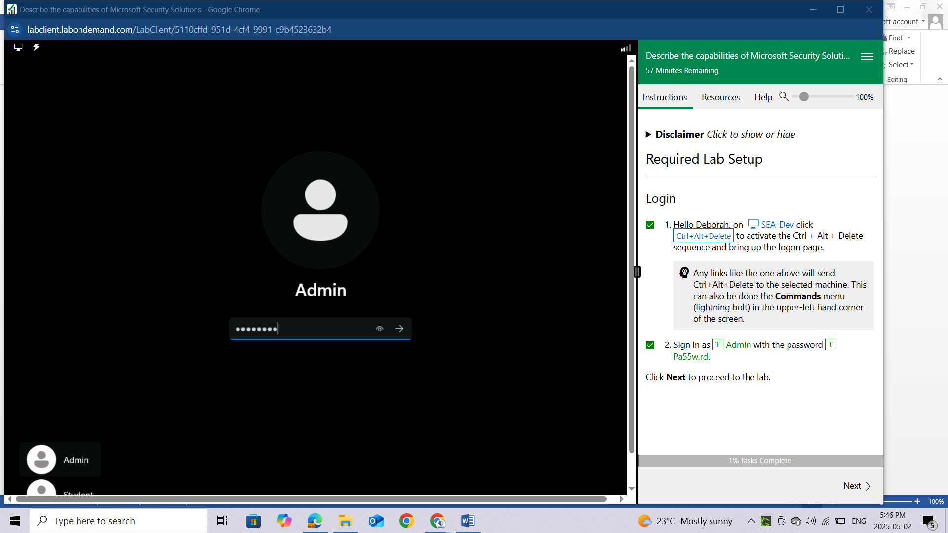

# LAB: SETUP OF THE MICROSOFT 365 TENANT

## Lab scenario

This setup lab consists of enabling the Microsoft Audit Log and file monitoring capabilities in the Microsoft 365 tenant.

## Setup - Enable Microsoft 365 audit log and file monitoring

In this setup task, you will enable the Audit log and file monitoring capabilities in Microsoft 365.

Open Microsoft Edge. In the address bar, enter https://admin.microsoft.com.

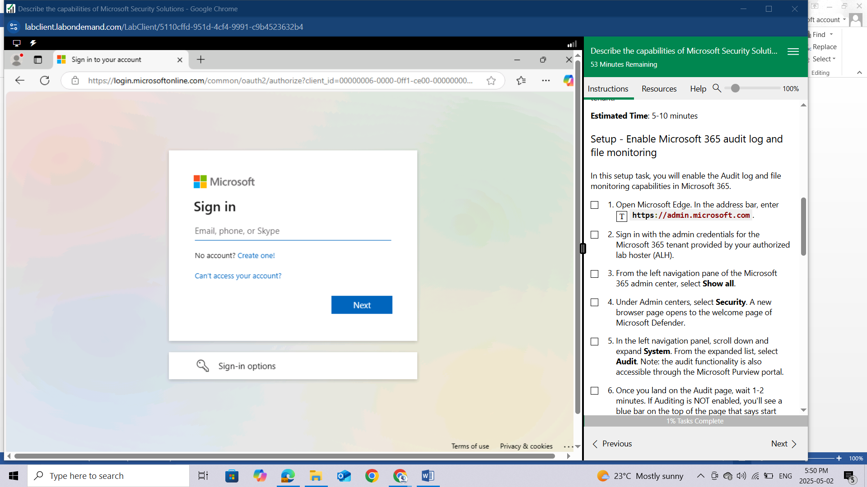

Sign in with the admin credentials for the Microsoft 365 tenant provided by your authorized lab hoster (ALH).

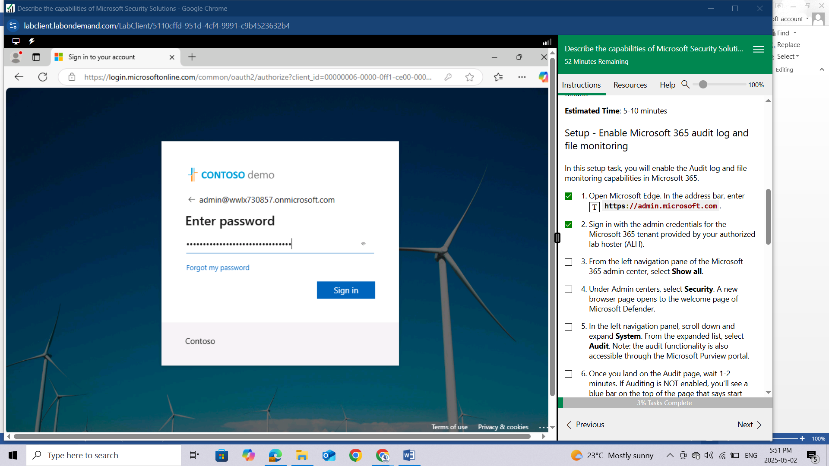

From the left navigation pane of the Microsoft 365 admin center, select **Show all.**

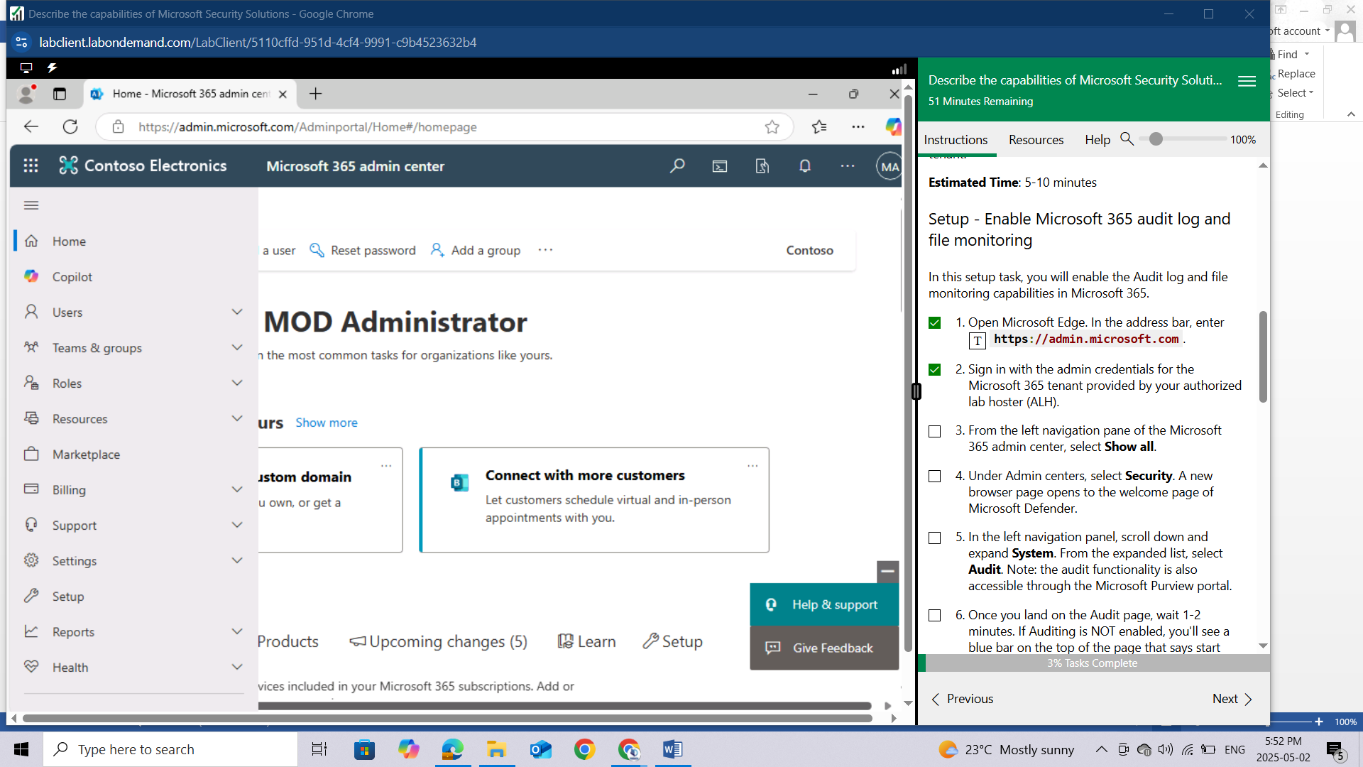

Under Admin centers, select **Security**. A new browser page opens to the welcome page of Microsoft Defender.

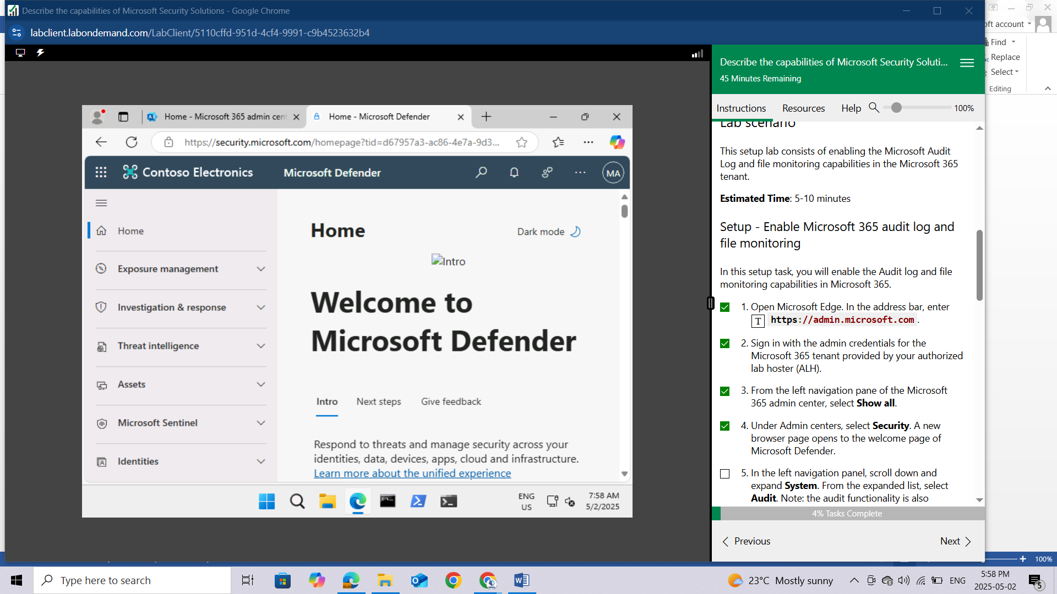

In the left navigation panel, scroll down and expand **System**. From the expanded list, select **Audit**. Note: the audit functionality is also accessible through the Microsoft Purview portal.

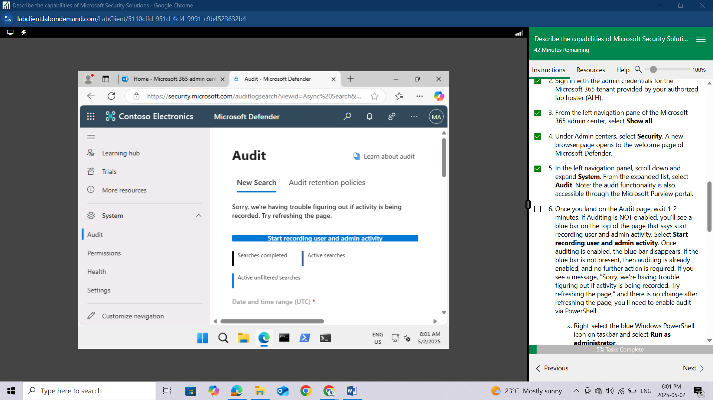

Once you land on the Audit page, wait 1-2 minutes. If Auditing is NOT enabled, you'll see a blue bar on the top of the page that says **start recording user and admin activity**. Select Start recording user and admin activity. Once auditing is enabled, the blue bar disappears. If the blue bar is not present, then auditing is already enabled, and no further action is required. If you see a message, "Sorry, we're having trouble figuring out if activity is being recorded. Try refreshing the page," and there is no change after refreshing the page, you'll need to enable audit via PowerShell.

Right-select the blue Windows PowerShell icon on taskbar and select **Run as administrator.**

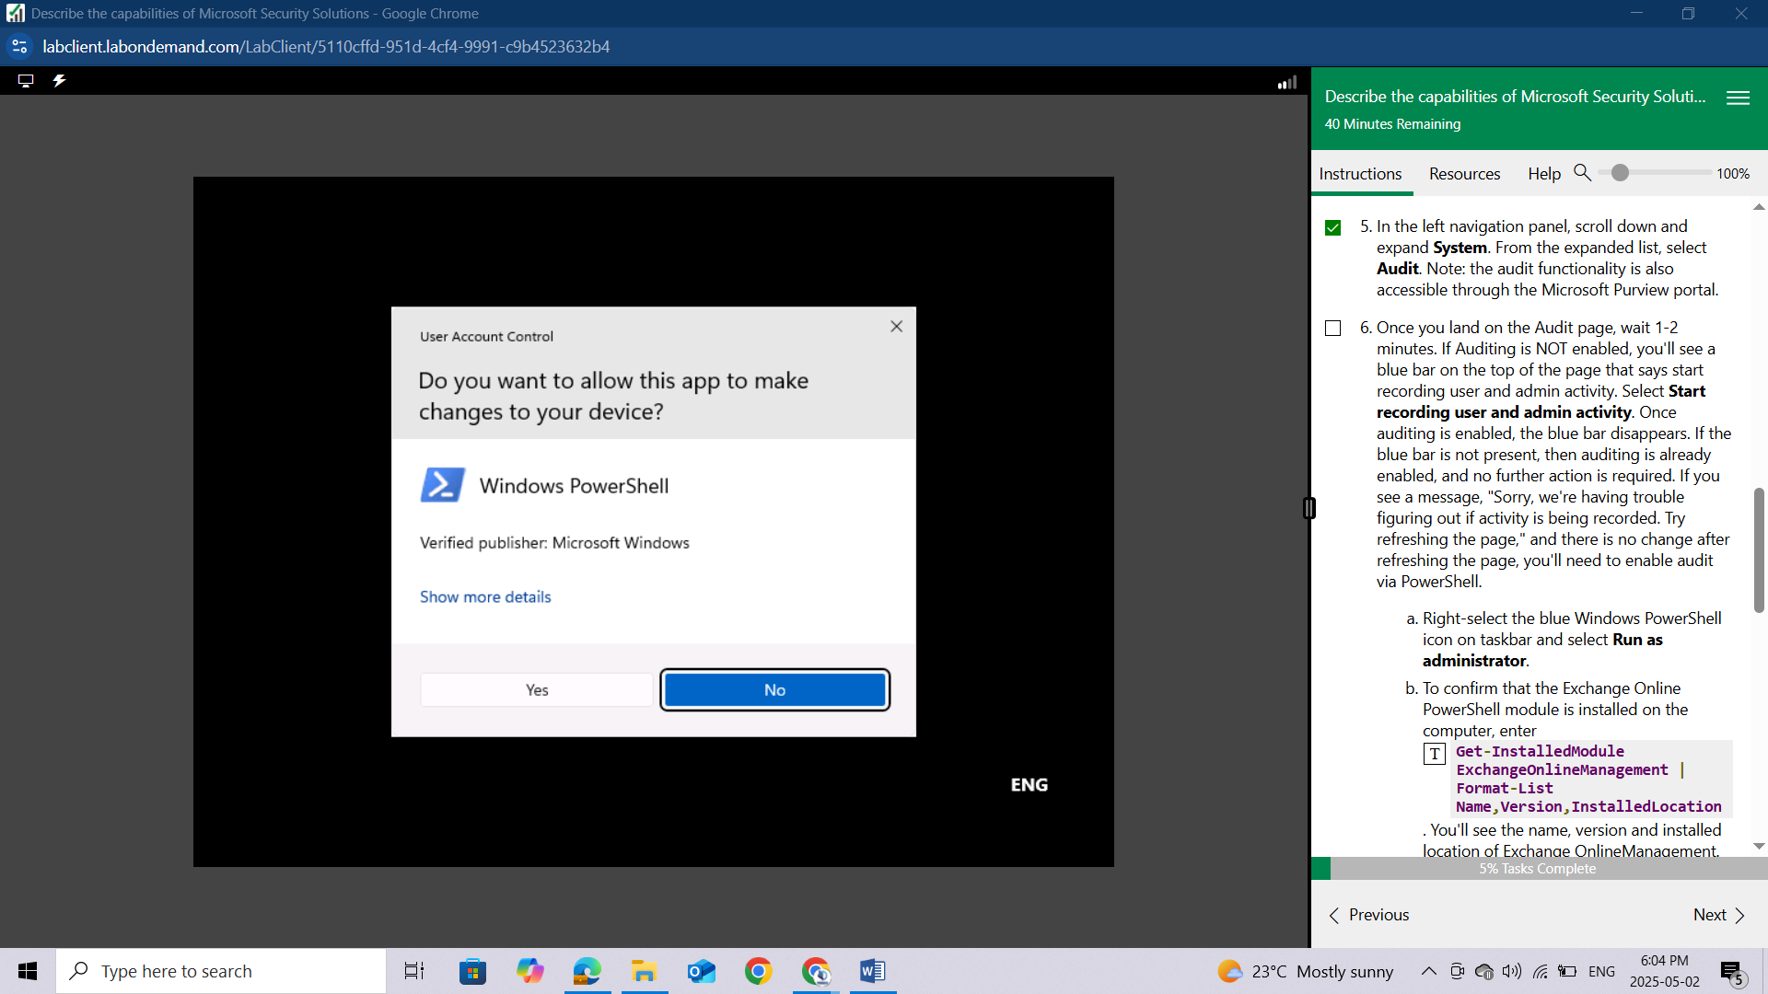

To confirm that the Exchange Online PowerShell module is installed on the computer, enter

**Get-InstalledModule ExchangeOnlineManagement | Format-List Name,Version,InstalledLocation.** You'll see the name, version and installed location of Exchange OnlineManagement.

If its not yet install you can install using the command: **Install-Module ExchangeOnlineManagement -Scope CurrentUser**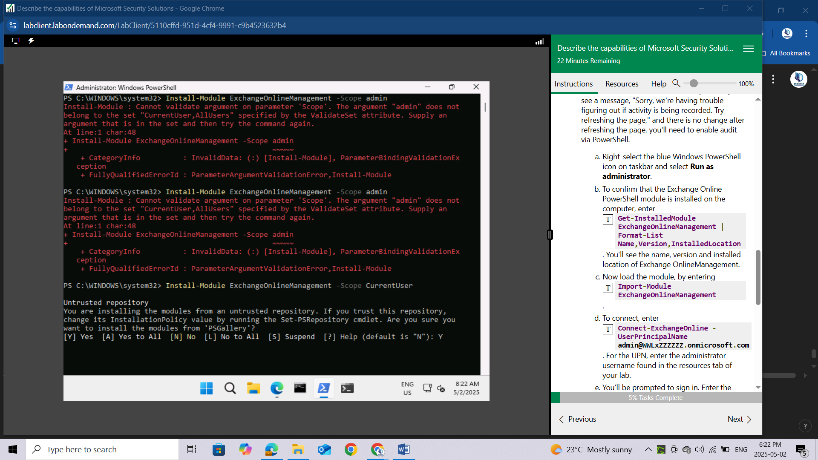

Confirm installation with: **Get-InstalledModule ExchangeOnlineManagement | Format-List Name,Version,InstalledLocation**

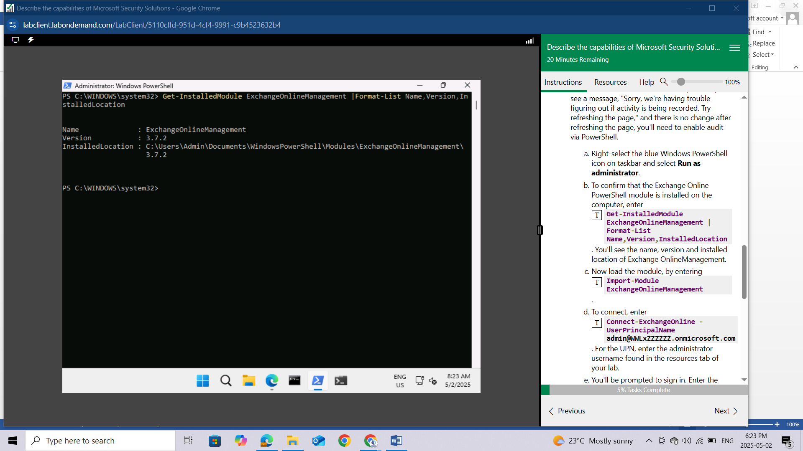

Now load the module, by entering **Import-Module ExchangeOnlineManagement**.

To connect, enter **Connect-ExchangeOnline -UserPrincipalName** [**admin@WWLxZZZZZZ.onmicrosoft.com**](mailto:admin@WWLxZZZZZZ.onmicrosoft.com)**.** For the UPN, enter the administrator username found in the resources tab of your lab.

You'll be prompted to sign in. Enter the administrative username and password found in the resources tab of your lab.

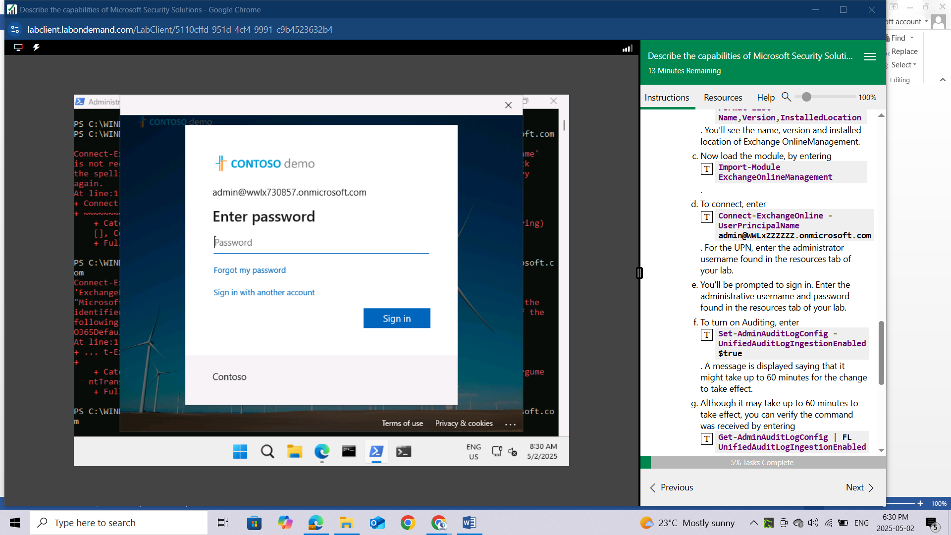

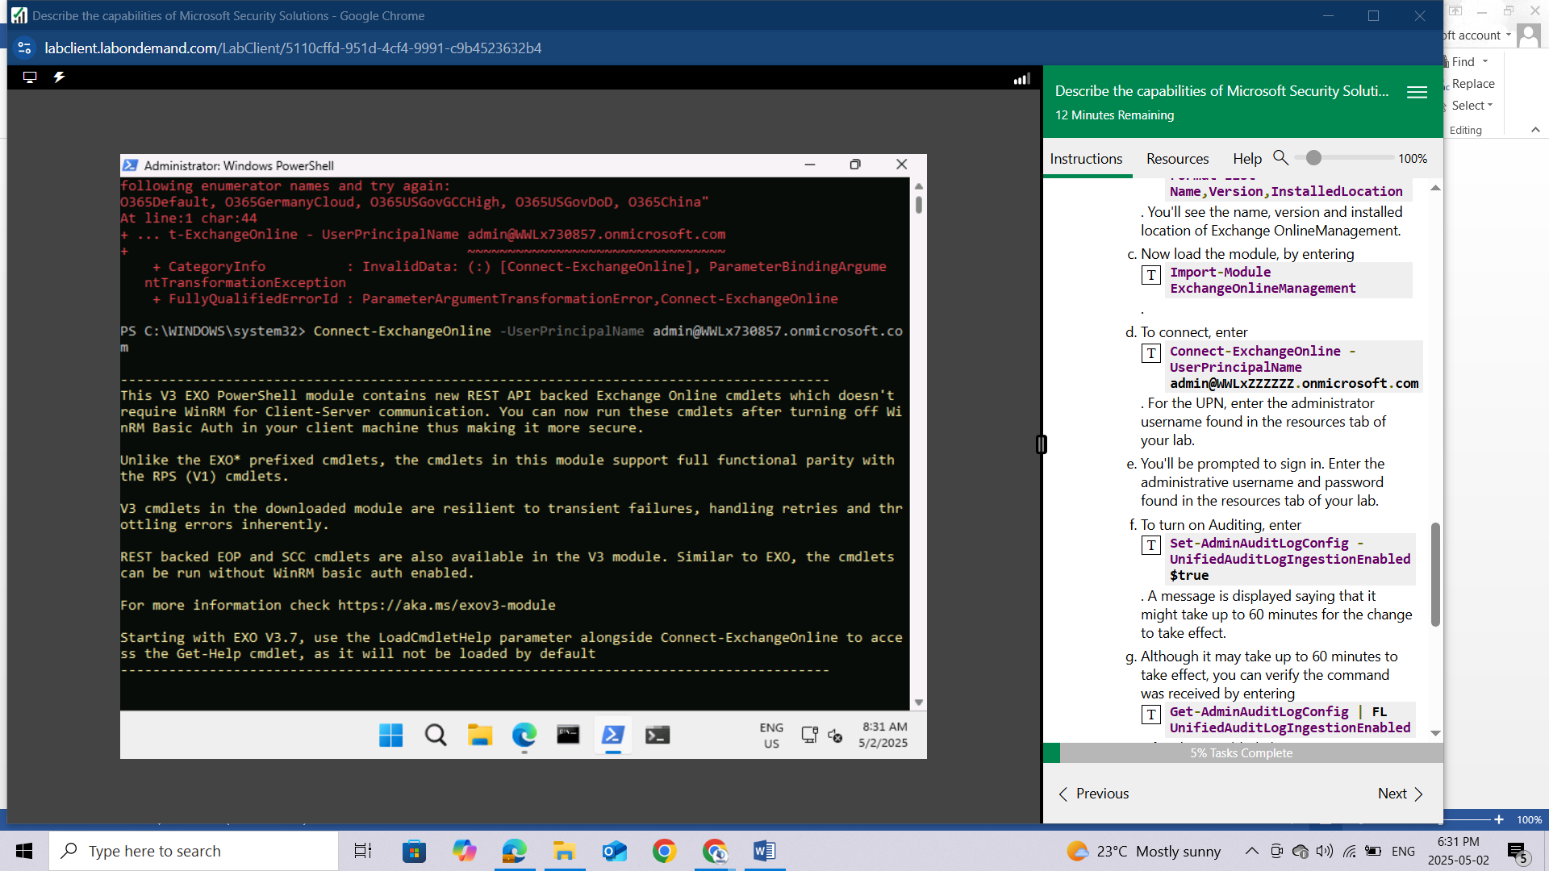

To turn on Auditing, enter **Set-AdminAuditLogConfig -UnifiedAuditLogIngestionEnabled $true**. A message is displayed saying that it might take up to 60 minutes for the change to take effect.

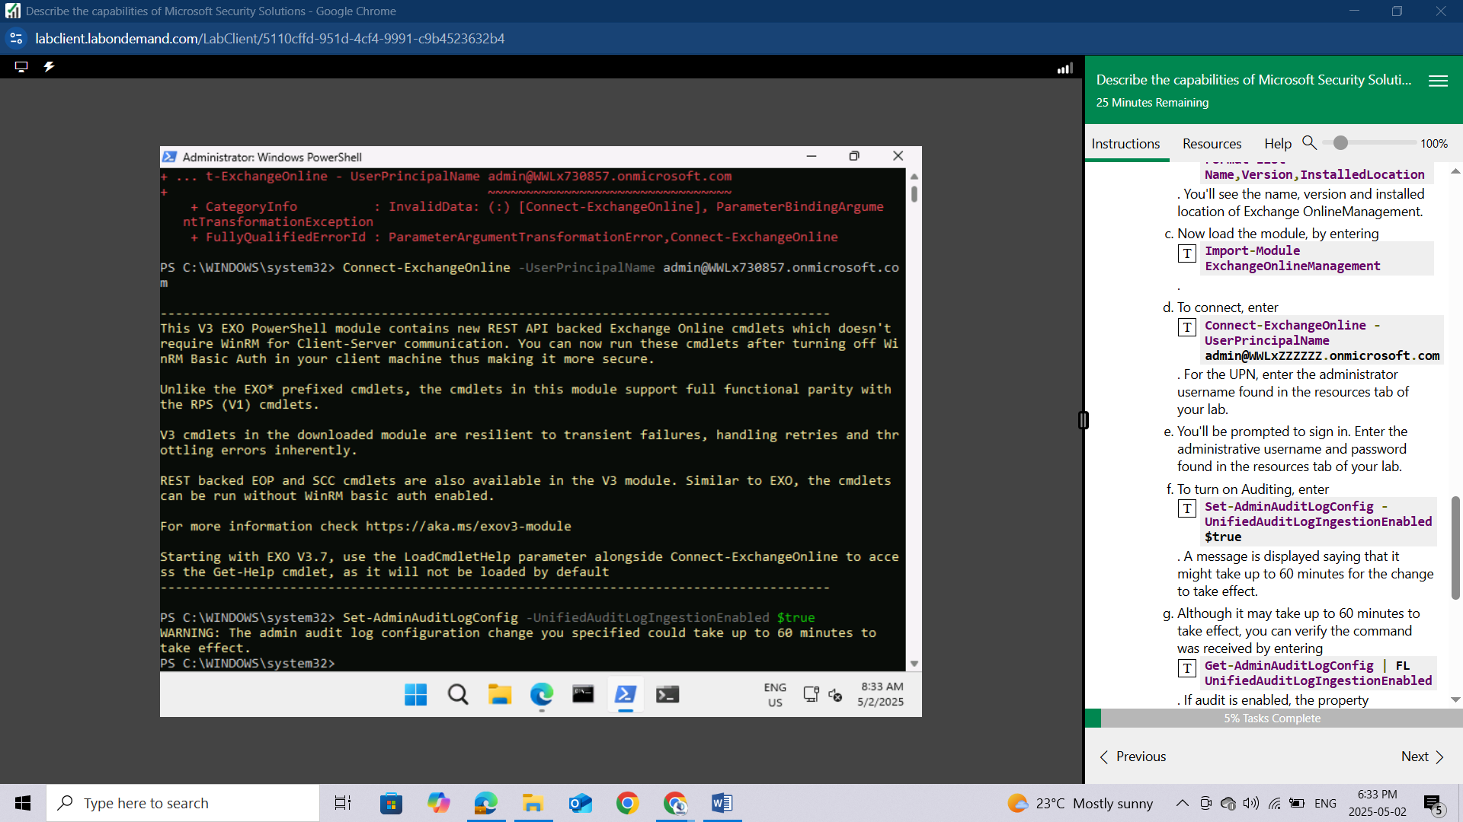

Although it may take up to 60 minutes to take effect, you can verify the command was received by entering **Get-AdminAuditLogConfig | FL UnifiedAuditLogIngestionEnabled**. If audit is enabled, the property **UnifiedAuditLogIngestionEnabled** will show a value of true.

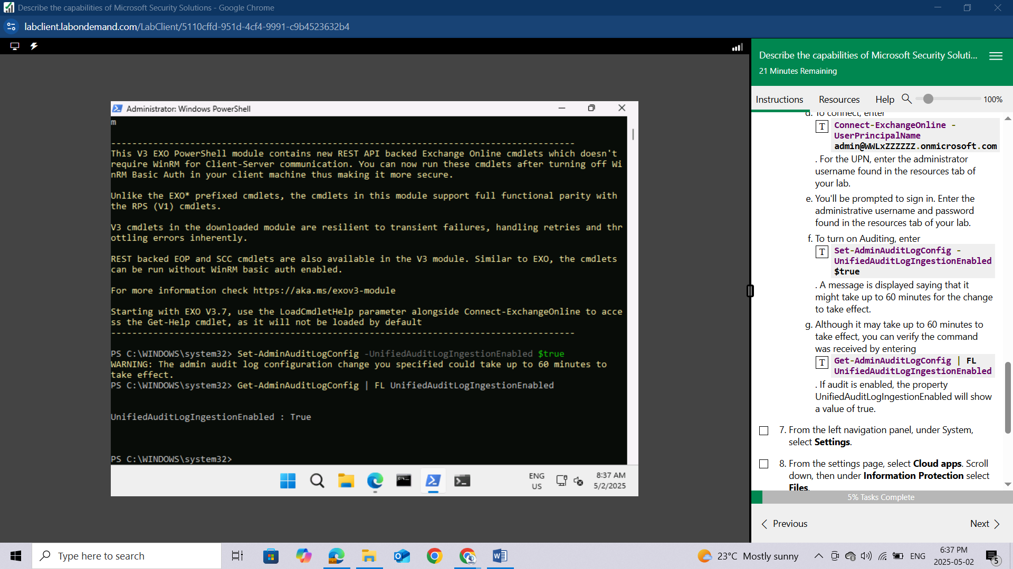

From the left navigation panel, under **System**, select **Settings**.

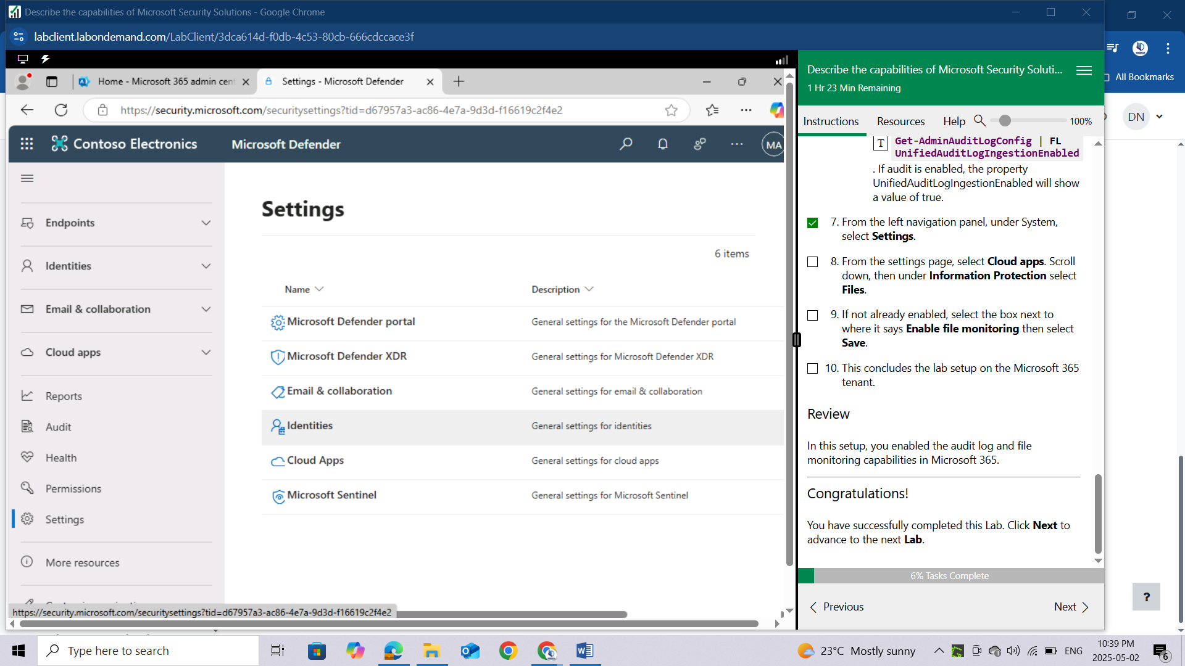

From the settings page, select **Cloud apps**. Scroll down, then under **Information Protection** select **Files**.

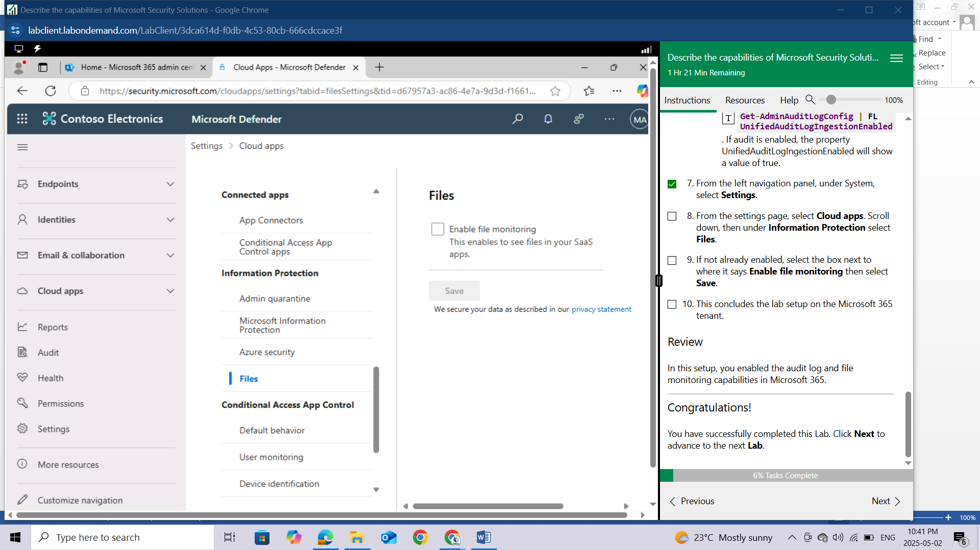

If not already enabled, select the box next to where it says **Enable file monitoring** then select **Save**.

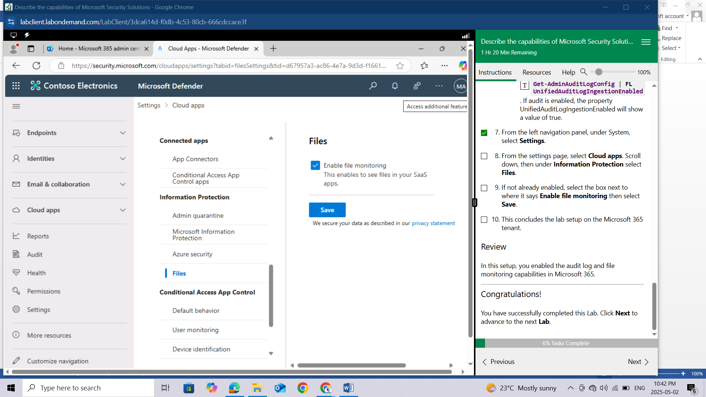

This concludes the lab setup on the Microsoft 365 tenant.

## REVIEW

In this setup, you enabled the audit log and file monitoring capabilities in Microsoft 365.

# LAB: EXPLORE AZURE NETWORK SECURITY GROUPS (NSGS)

This lab maps to the following Learn content:

* Learning Path: Describe the capabilities of Microsoft security solutions
* Module: Describe the basic security capabilities in Azure
* Unit: Describe Azure Network Security groups

## LAB SCENARIO

In this lab, you'll explore the function of network security groups in Azure. You'll do this by creating a network security group (NSG) and assigning the NSG to the interface of a pre-existing virtual machine (VM). Once configured you'll observe the default inbound and outbound rules, create new rules, and test those rules. In this lab, the VM you'll use with the NSG is created for you, so you'll first view some of the information associated with that VM.

## Task 1

In this task, you'll view some of the parameters associated with the VM that that was created for use with this lab.

Open Microsoft Edge. In the address bar, enter <https://portal.azure.com>.

Sign in with your Azure Portal admin credentials.

In the Sign-in window, enter the username provided by your lab hosting provider then select Next.

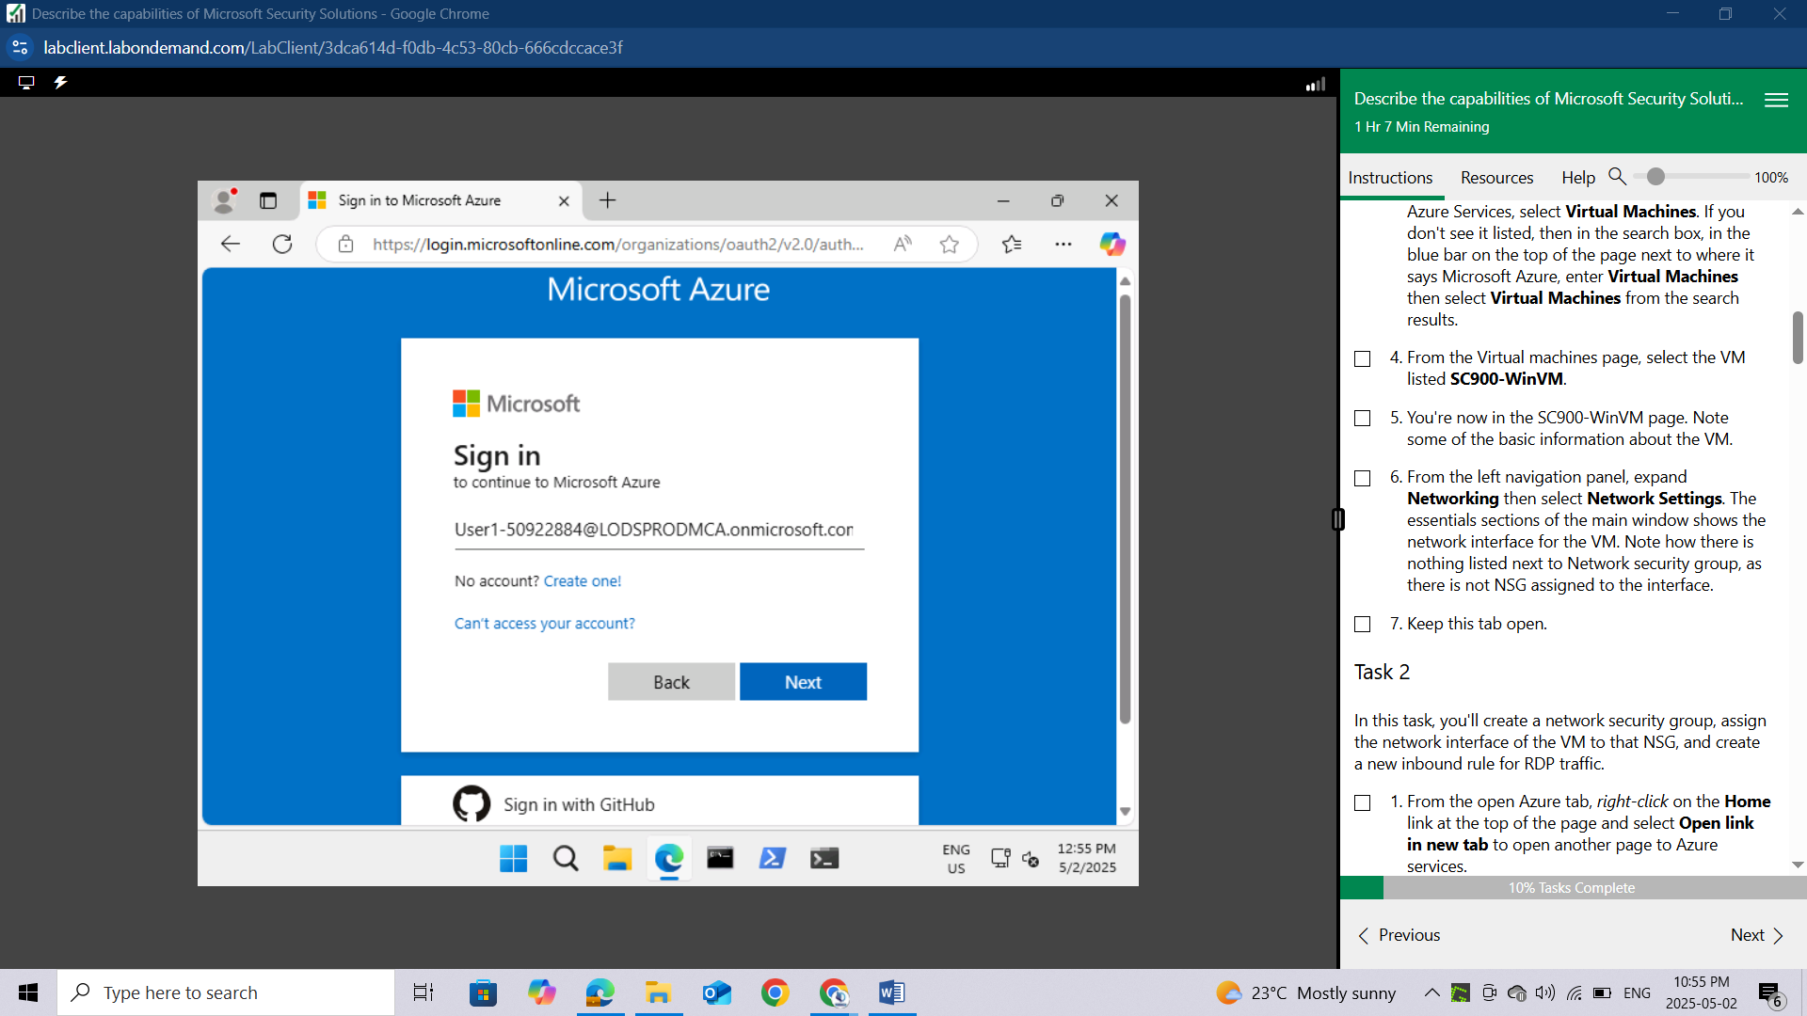

Enter the admin password that should be provided by your lab hosting provider. Select Sign in.

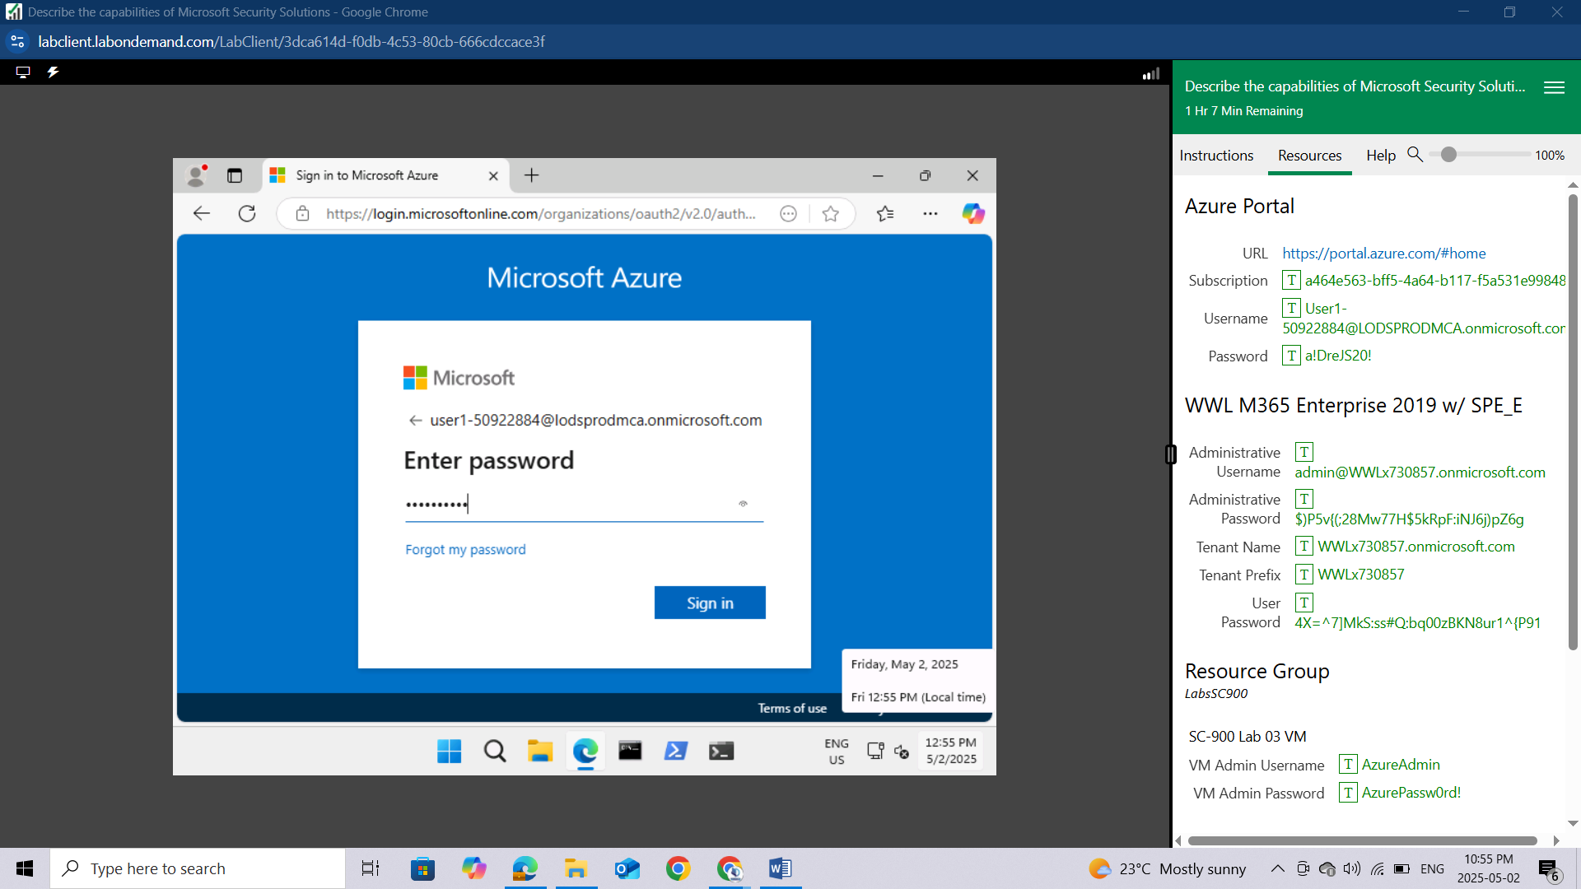

Depending on your lab hoster and if this is the first time you are logging in to the tenant, you may be prompted to complete the MFA registration process. If so, follow the prompts on the screen to setup MFA.

On the top of the page, underneath where it says Azure Services, select **Virtual Machines**. If you don't see it listed, then in the search box, in the blue bar on the top of the page next to where it says Microsoft Azure, enter **Virtual** **Machines** then select **Virtual Machines** from the search results.

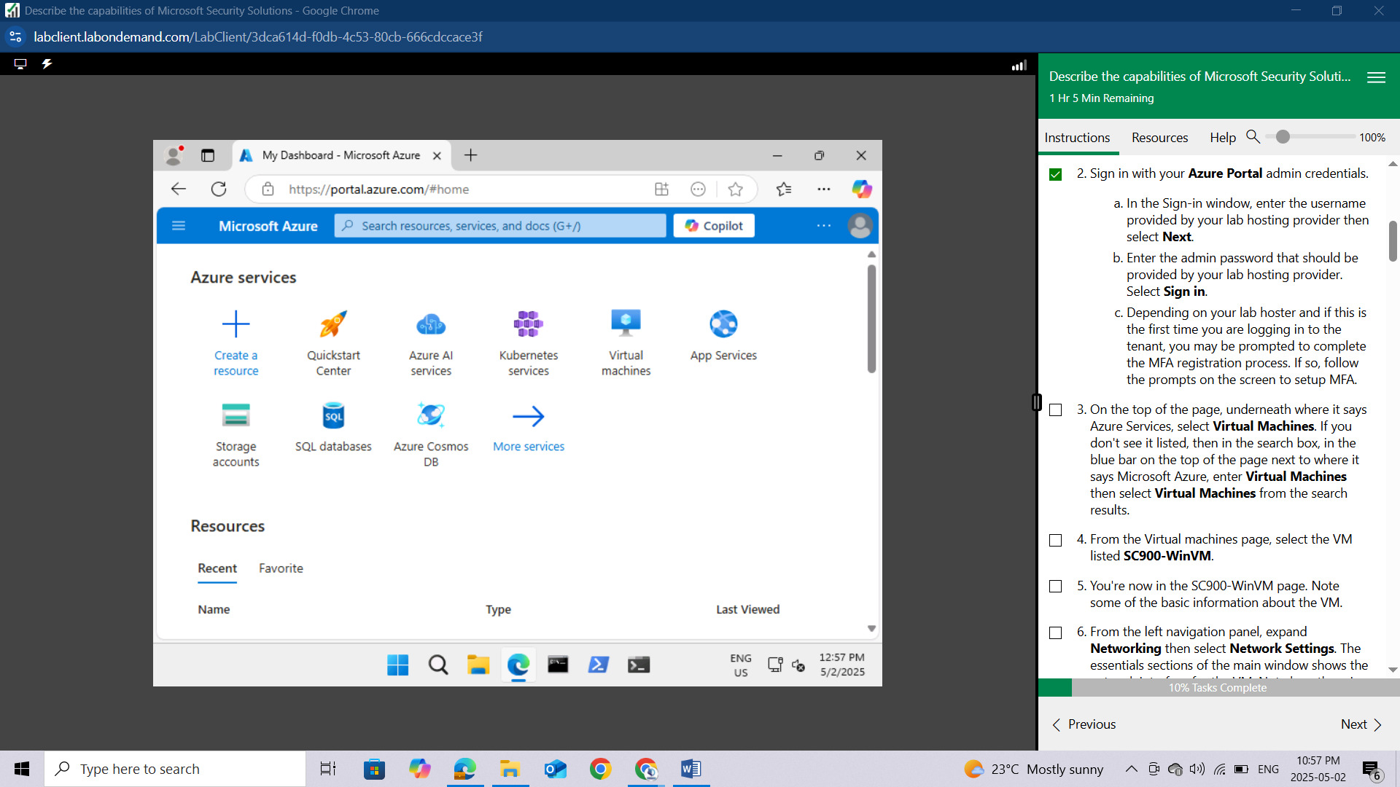

From the Virtual machines page, select the VM listed **SC900-WinVM.**

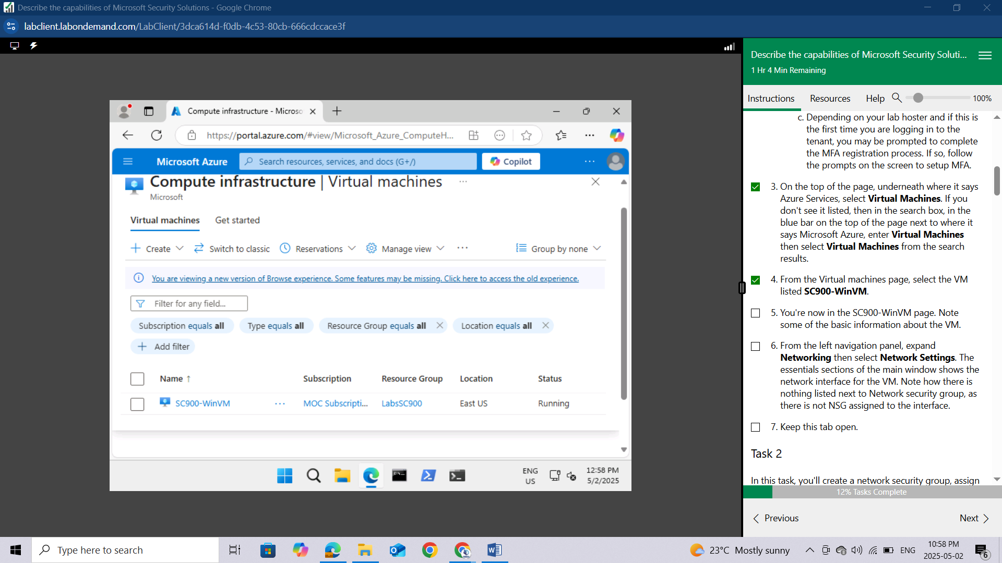

You're now in the **SC900-WinVM page**. Note some of the basic information about the VM.

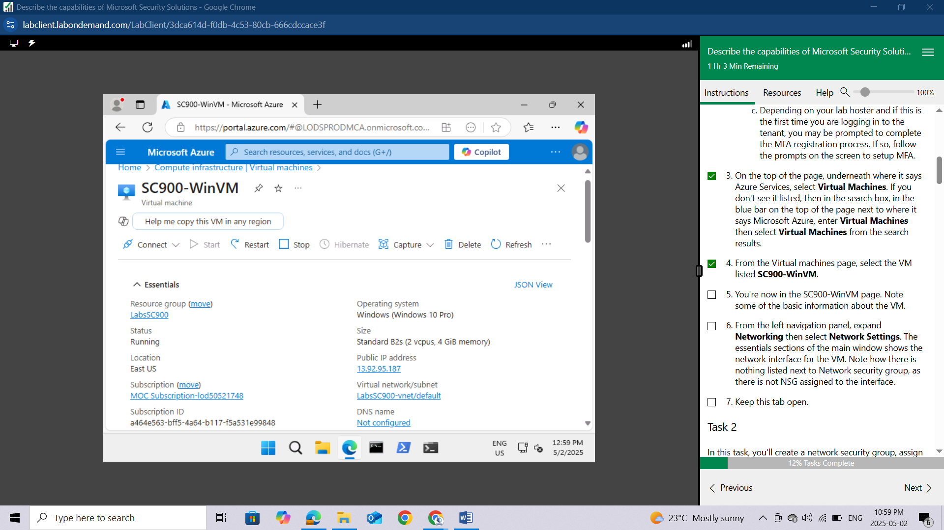

From the left navigation panel, expand **Networking** then select **Network Settings**. The essentials sections of the main window shows the network interface for the VM. Note how there is nothing listed next to Network security group, as there is not NSG assigned to the interface.

Keep this tab open.

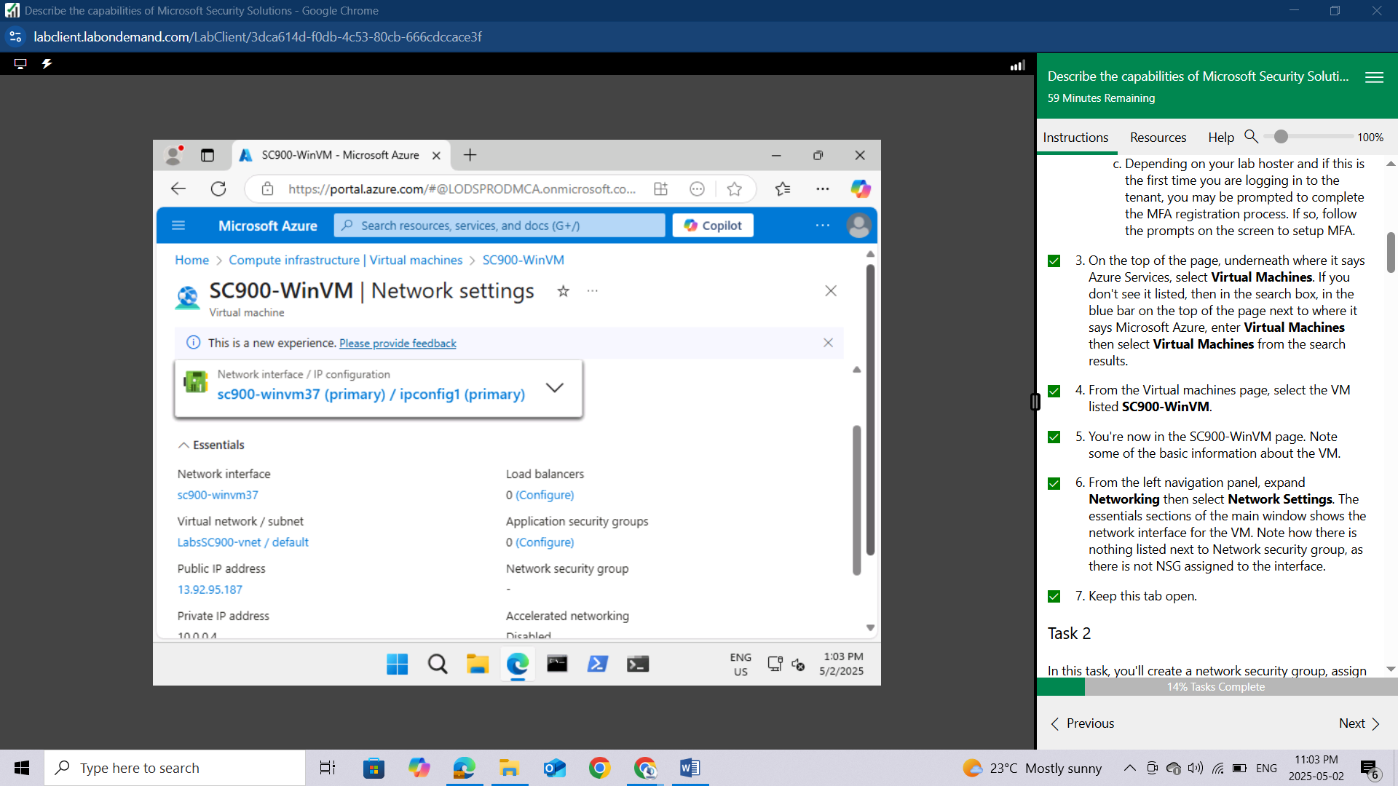

## Task 2

In this task, you'll create a network security group, assign the network interface of the VM to that NSG, and create a new inbound rule for RDP traffic.

From the open Azure tab, right-click on the **Home** link at the top of the page and select **Open link in new tab** to open another page to Azure services.

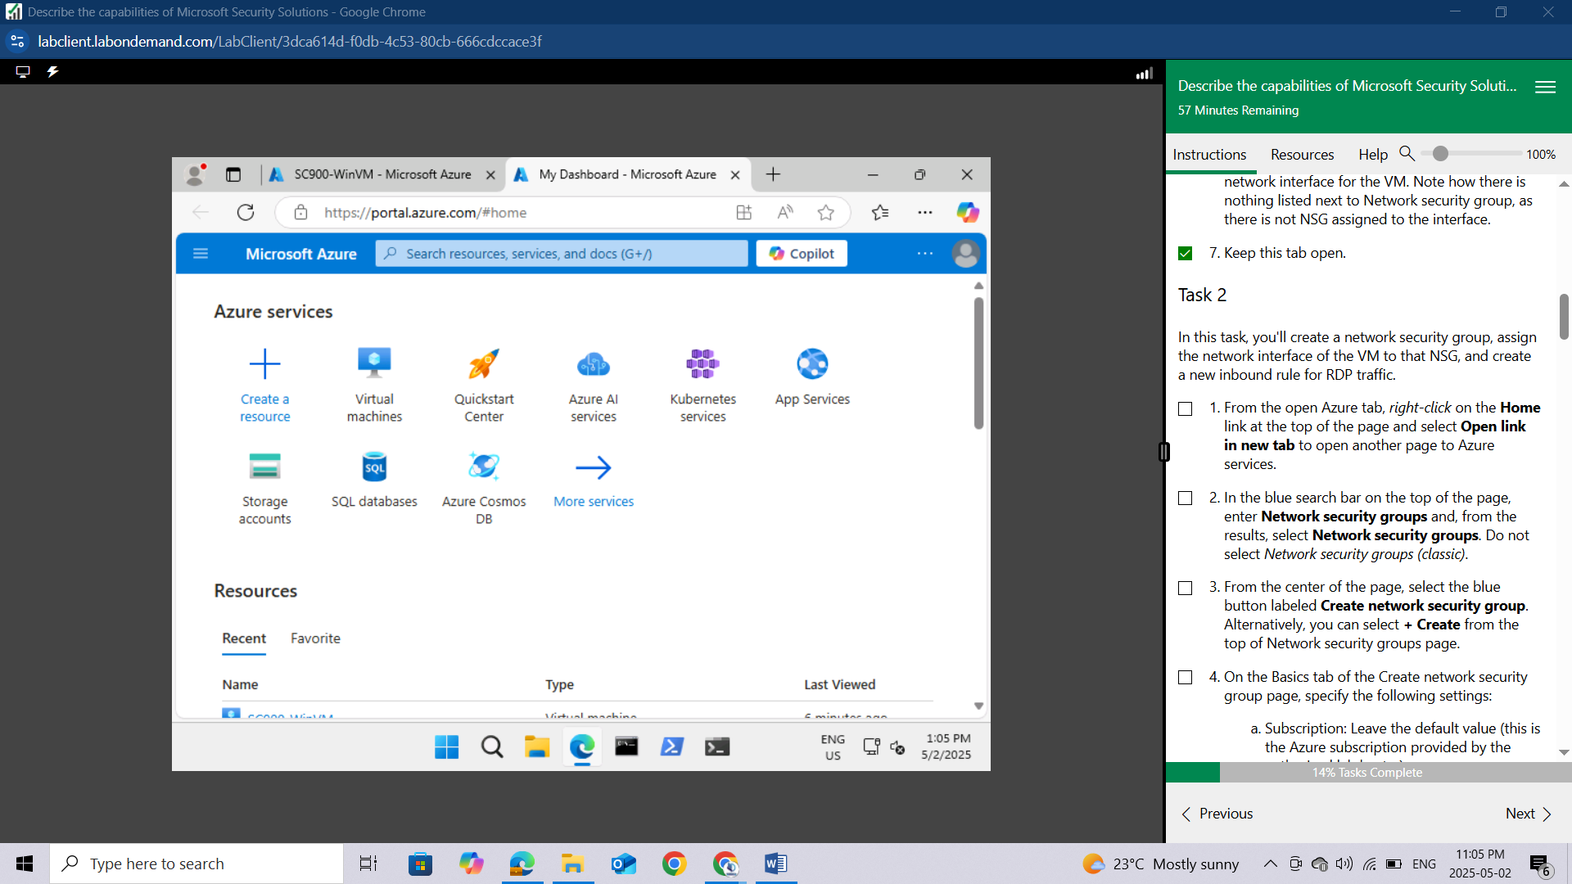

In the blue search bar on the top of the page, enter **Network security groups** and, from the results, select **Network security groups**. Do not select **Network security groups (classic).**

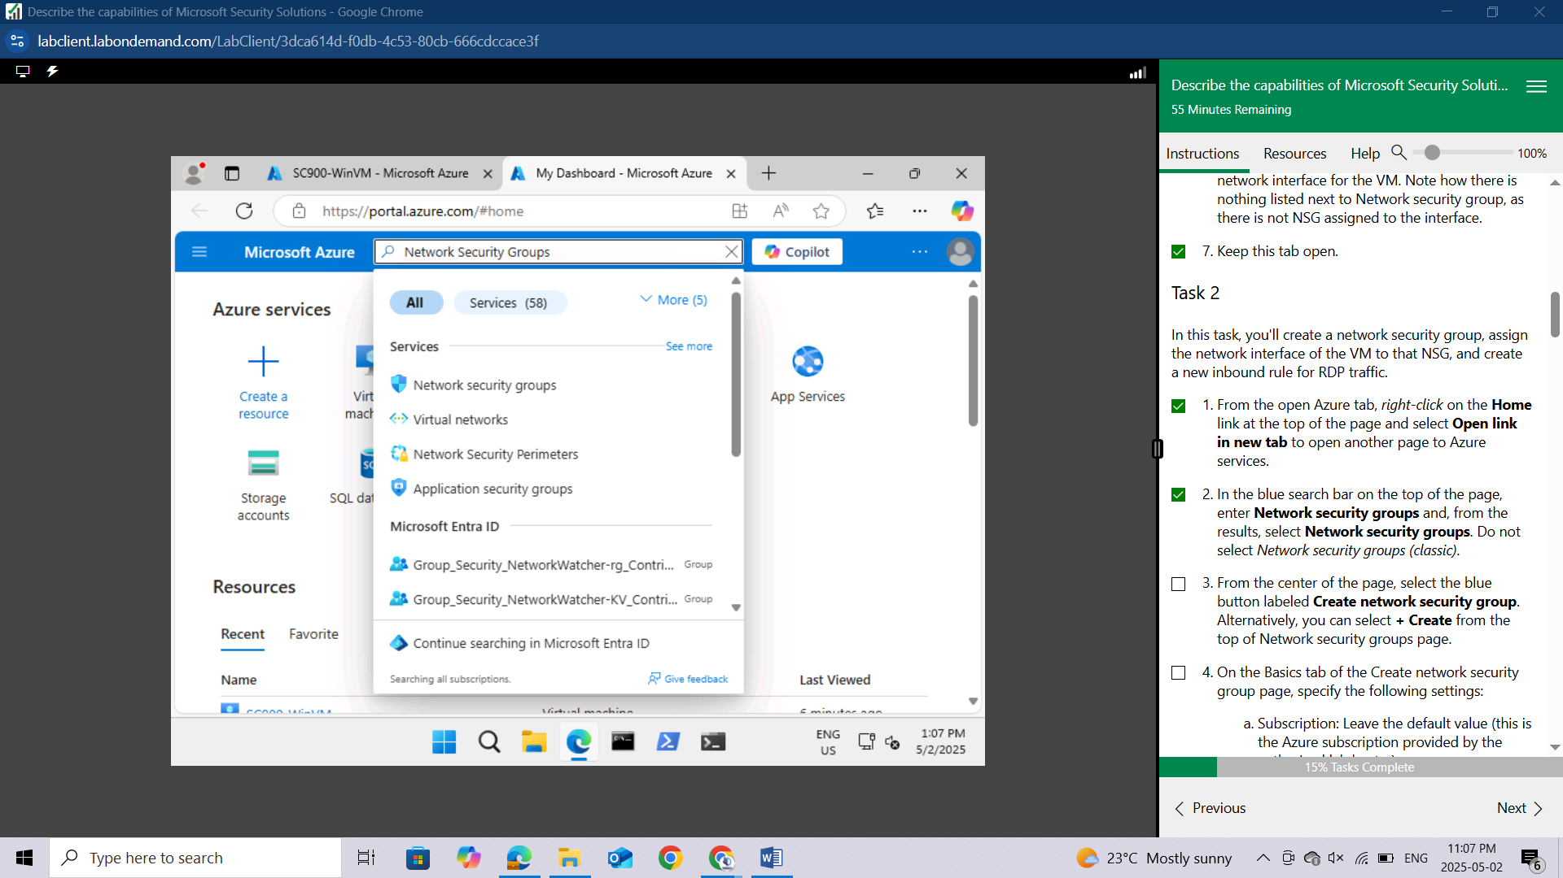

From the center of the page, select the blue button labeled **Create network security group**. Alternatively, you can select **+ Create** from the top of Network security groups page.

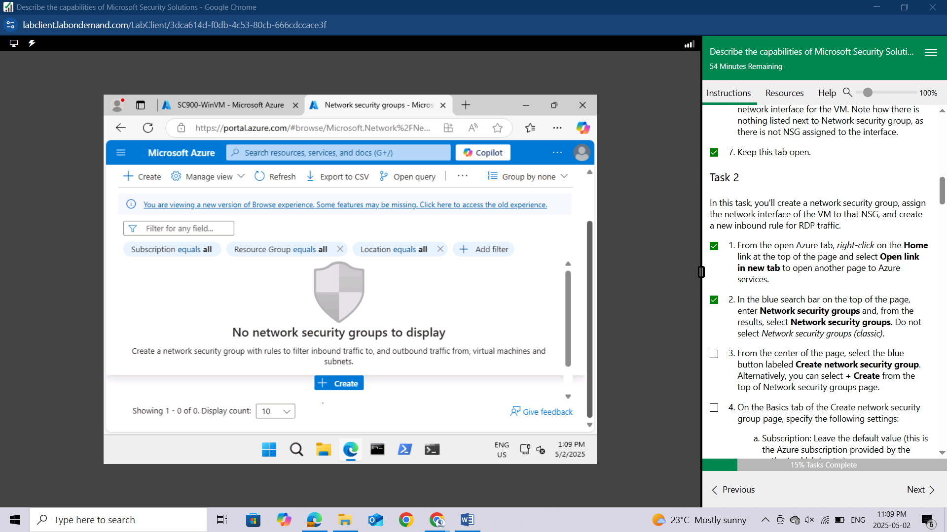

On the Basics tab of the Create network security group page, specify the following settings:

**Subscription**: Leave the default value (this is the Azure subscription provided by the authorized lab hoster)

Resource group: **LabsSC900**

Name: **NSG-SC900**

Region: leave the default.

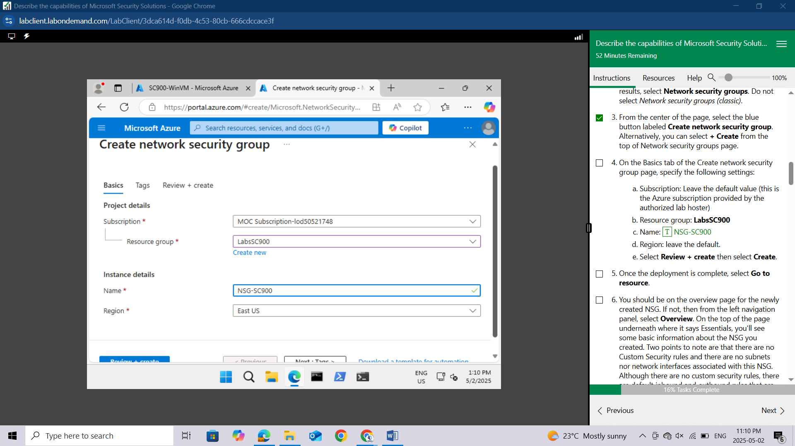

Select **Review + create** then select **Create.**

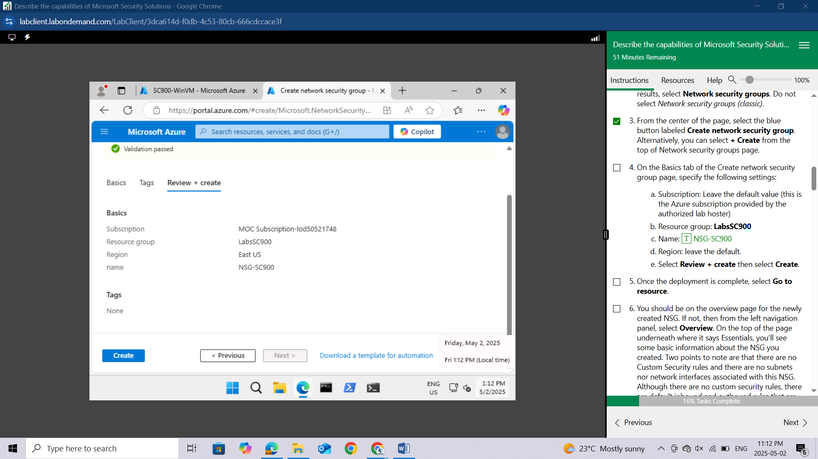

Once the deployment is complete, select **Go to resource**.

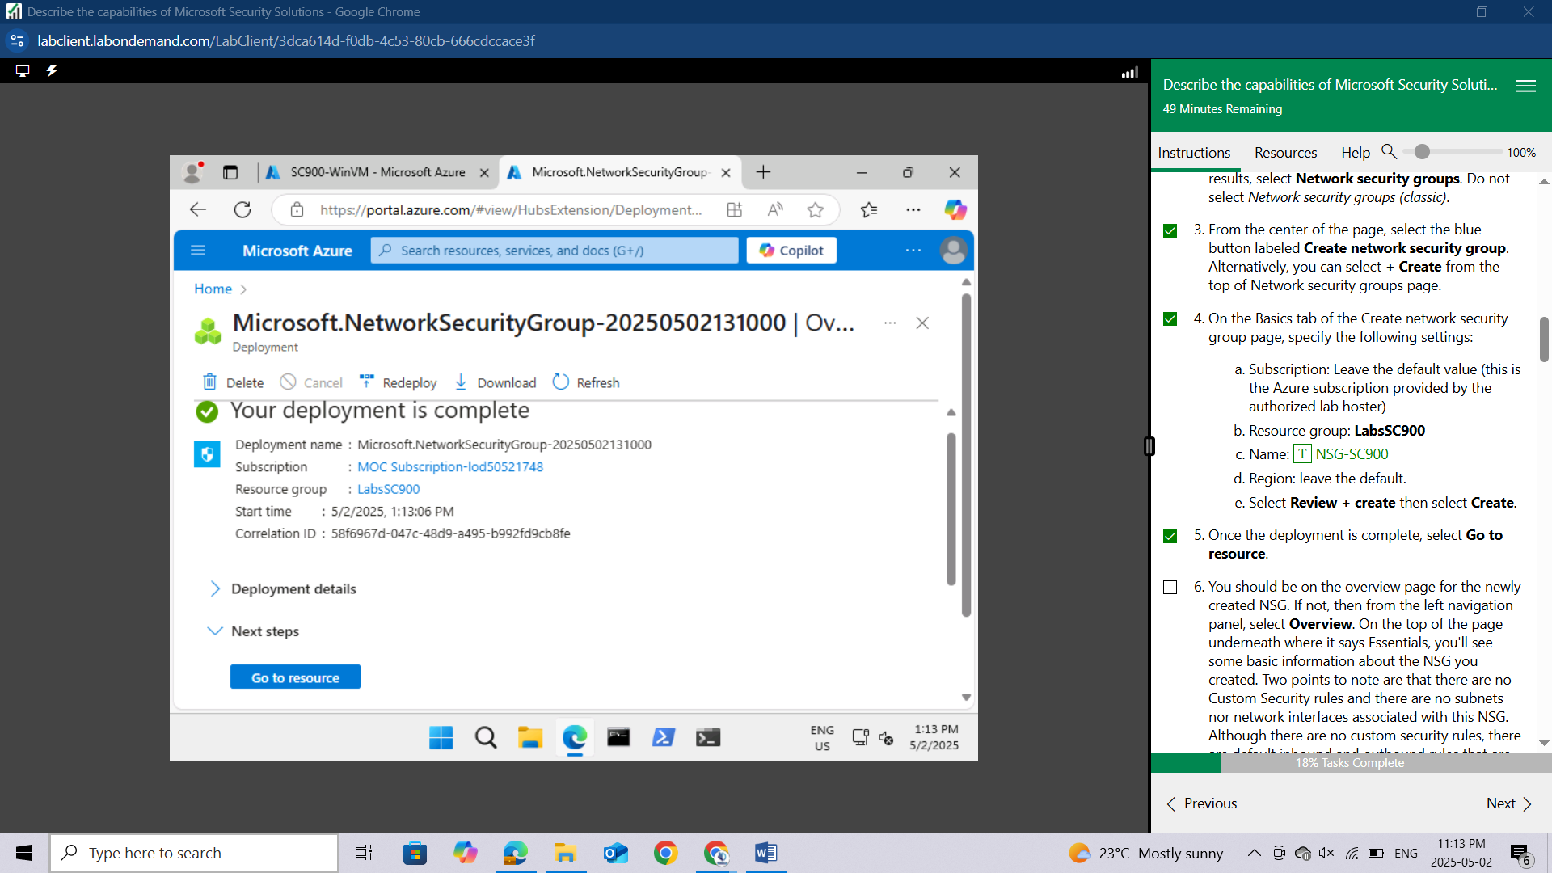

You should be on the overview page for the newly created NSG. If not, then from the left navigation panel, select **Overview**. On the top of the page underneath where it says Essentials, you'll see some basic information about the NSG you created. Two points to note are that there are no Custom Security rules and there are no subnets nor network interfaces associated with this NSG.

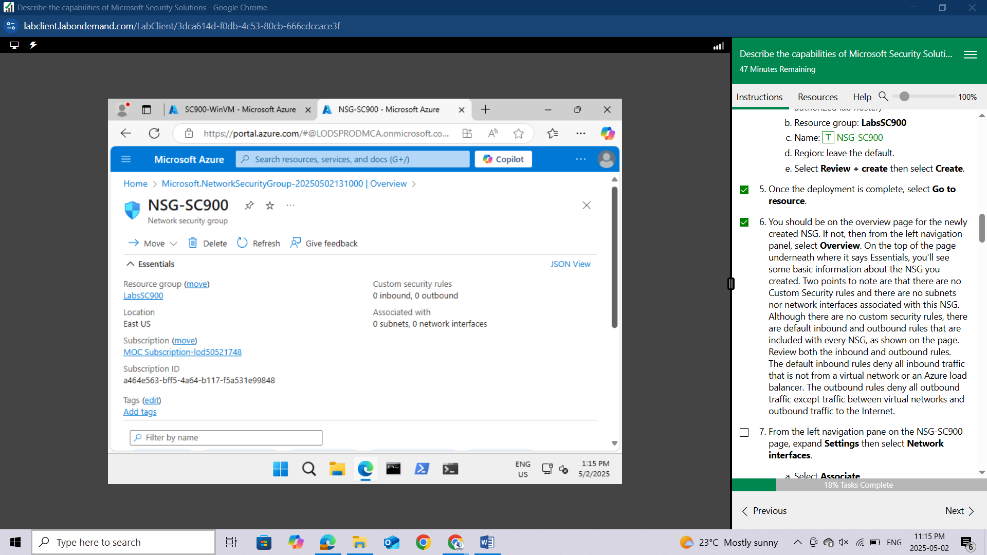

Although there are no custom security rules, there are default inbound and outbound rules that are included with every NSG, as shown on the page. Review both the inbound and outbound rules. The default inbound rules deny all inbound traffic that is not from a virtual network or an Azure load balancer. The outbound rules deny all outbound traffic except traffic between virtual networks and outbound traffic to the Internet.

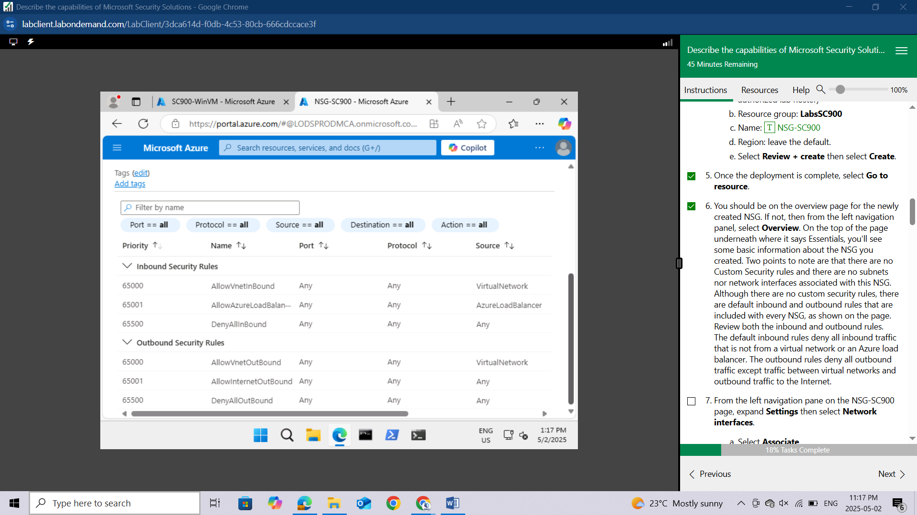

From the left navigation pane on the NSG-SC900 page, expand **Settings** then select **Network interfaces.**

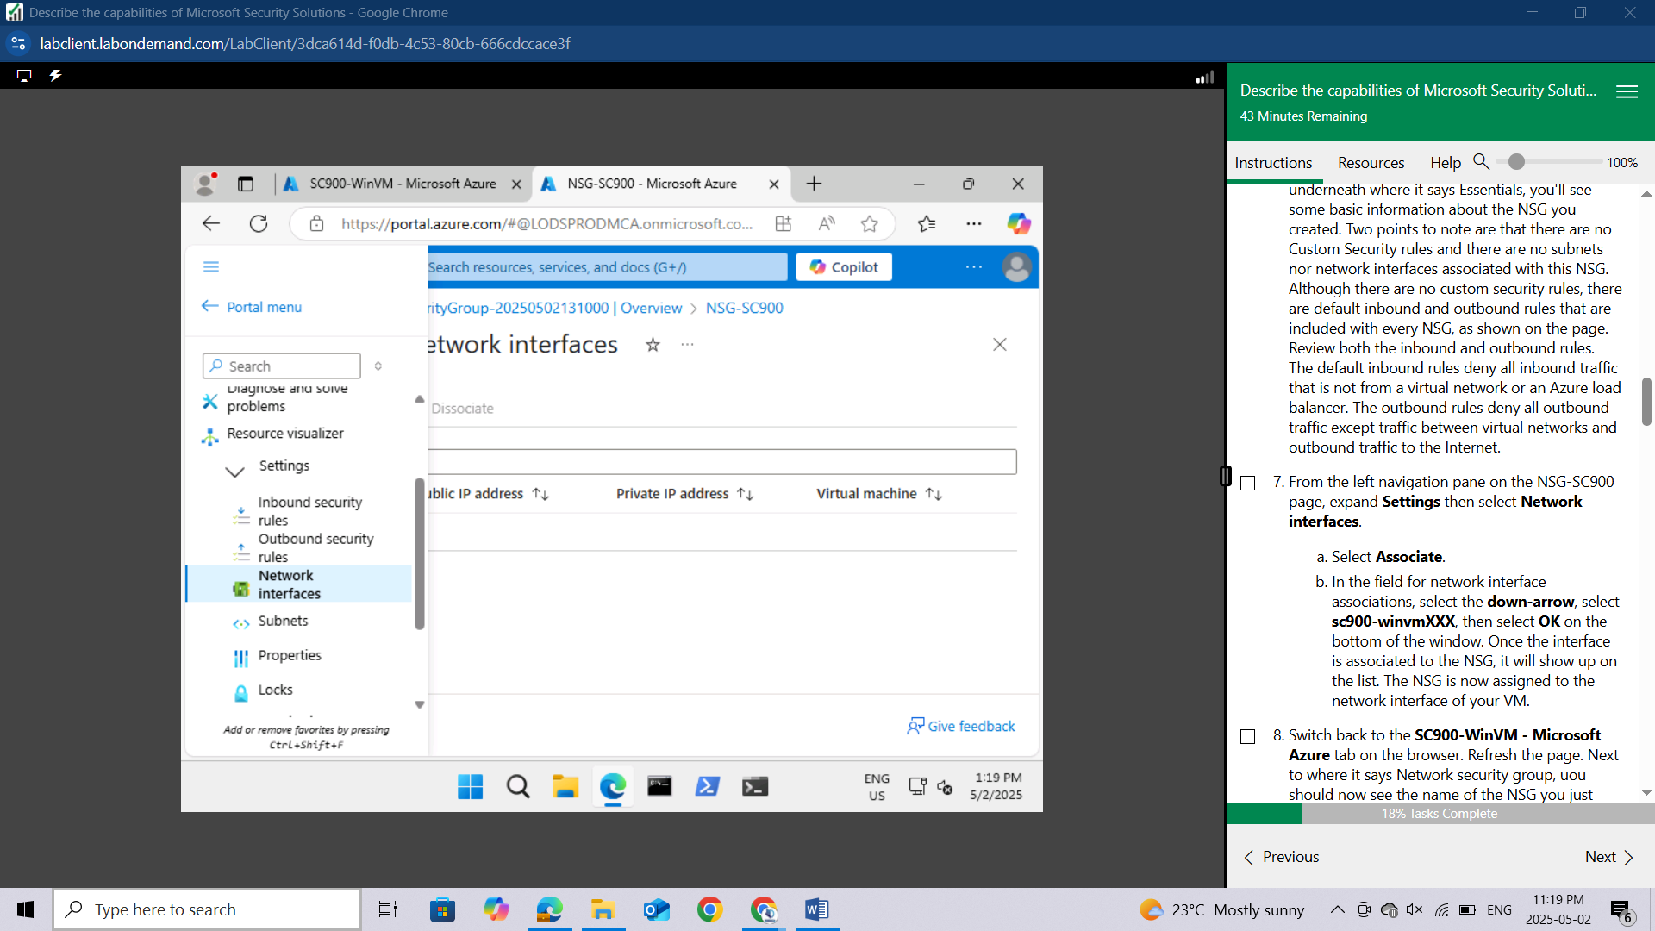

Select **Associate**.

In the field for network interface associations, select the **down-arrow**, select **sc900-winvmXXX**, then select **OK** on the bottom of the window. Once the interface is associated to the NSG, it will show up on the list. 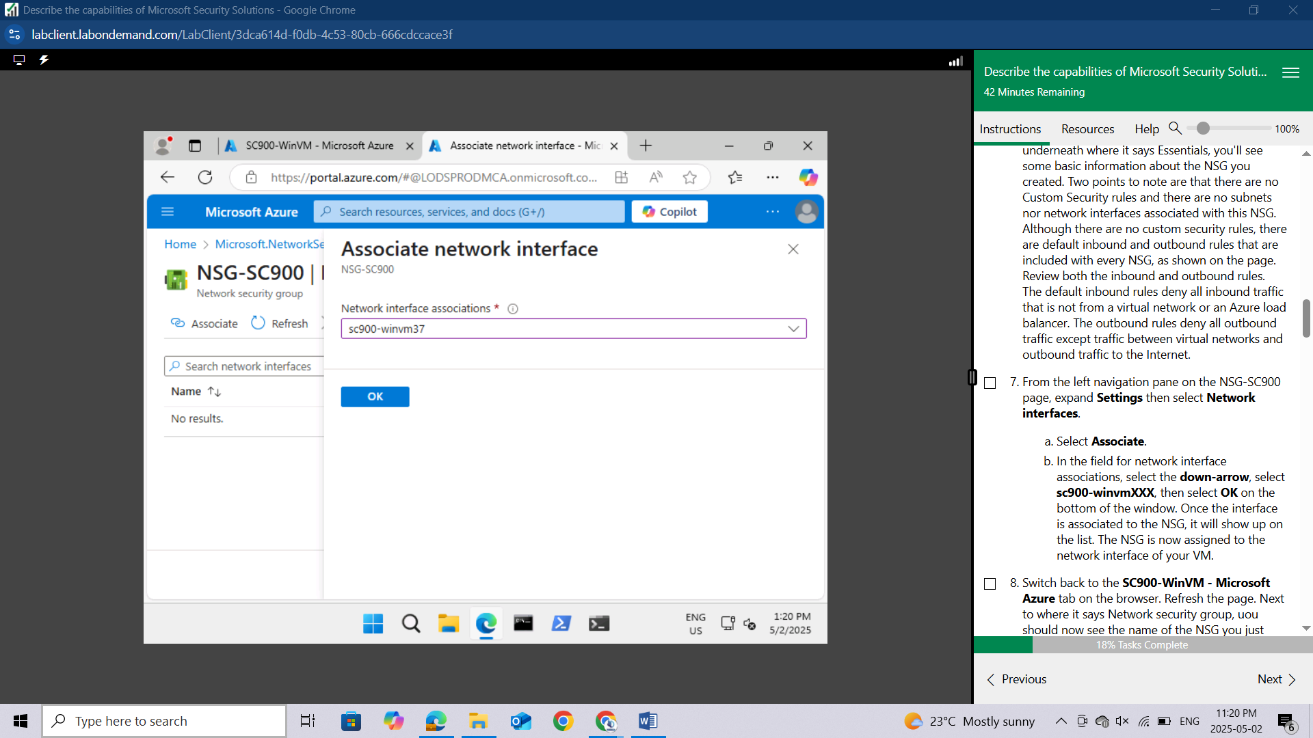

The NSG is now assigned to the network interface of your VM.

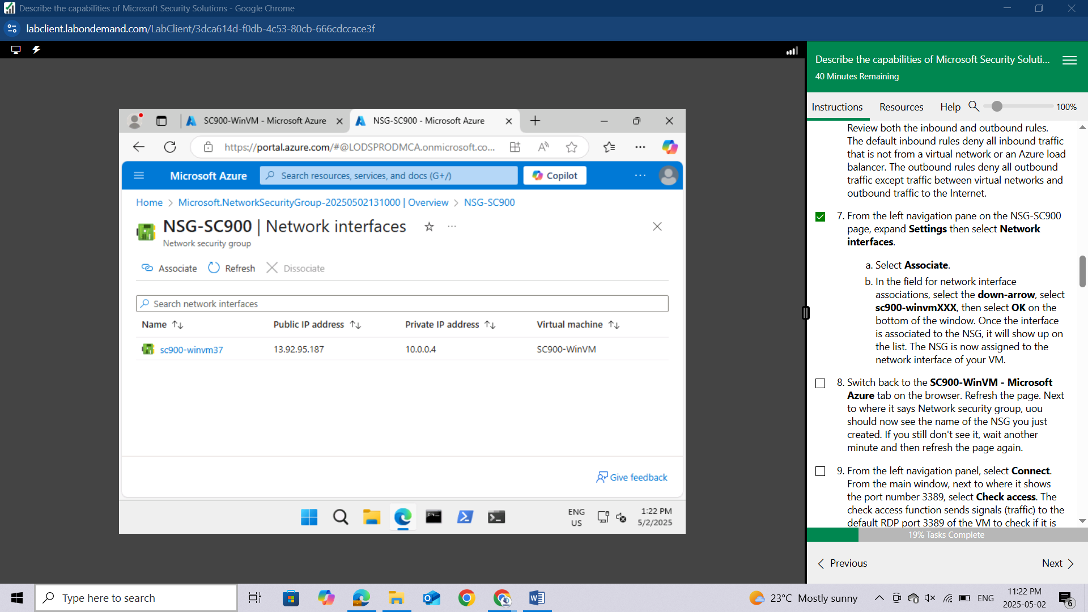

Switch back to the **SC900-WinVM - Microsoft Azure** tab on the browser. Refresh the page. Next to where it says Network security group, you should now see the name of the NSG you just created. If you still don't see it, wait another minute and then refresh the page again.

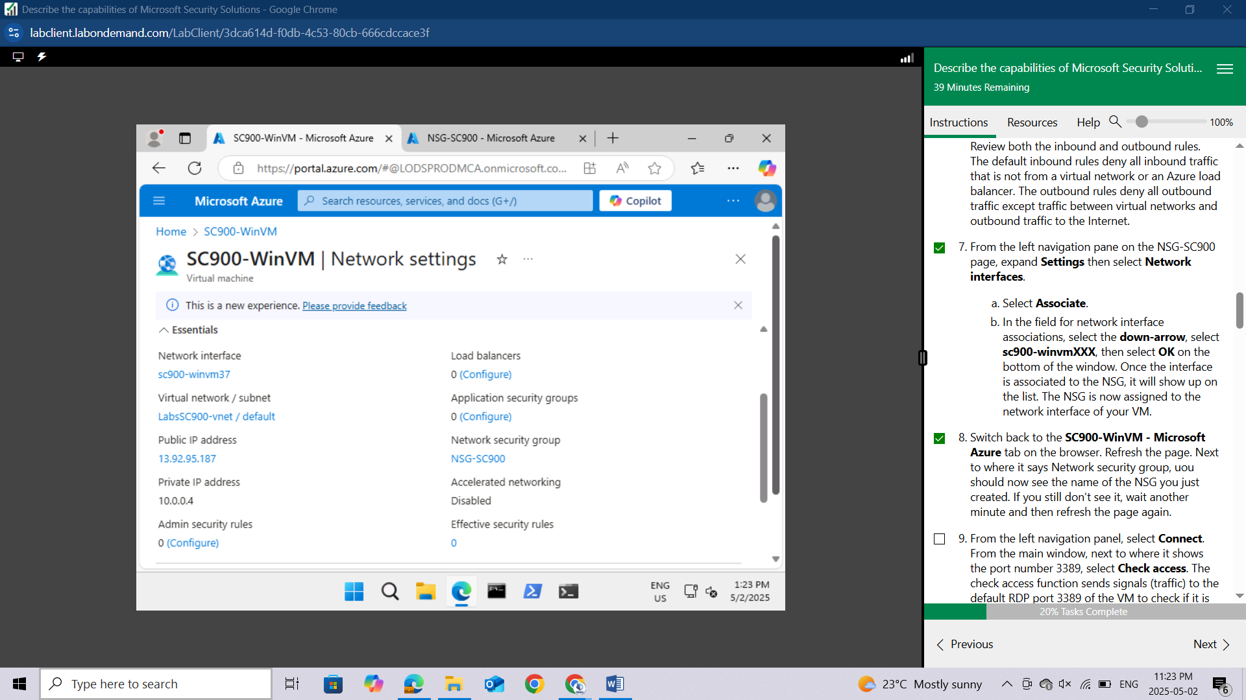

From the left navigation panel, select **Connect**.

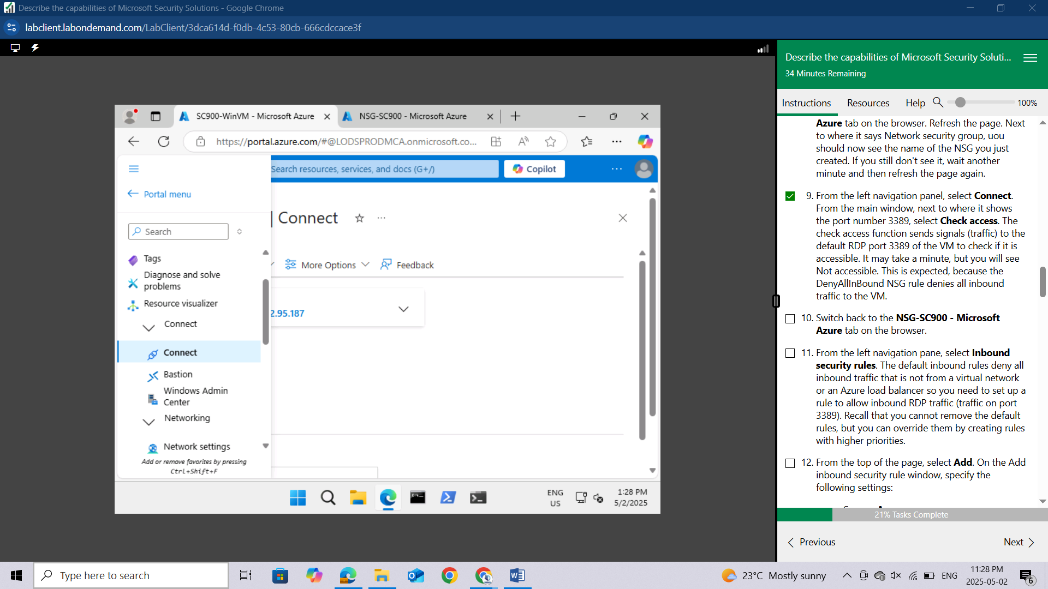

From the main window, next to where it shows the port number **3389**, select **Check access.** The check access function sends signals (traffic) to the default RDP port 3389 of the VM to check if it is accessible. It may take a minute, but you will see **Not accessible**. This is expected, because the DenyAllInBound NSG rule denies all inbound traffic to the VM.

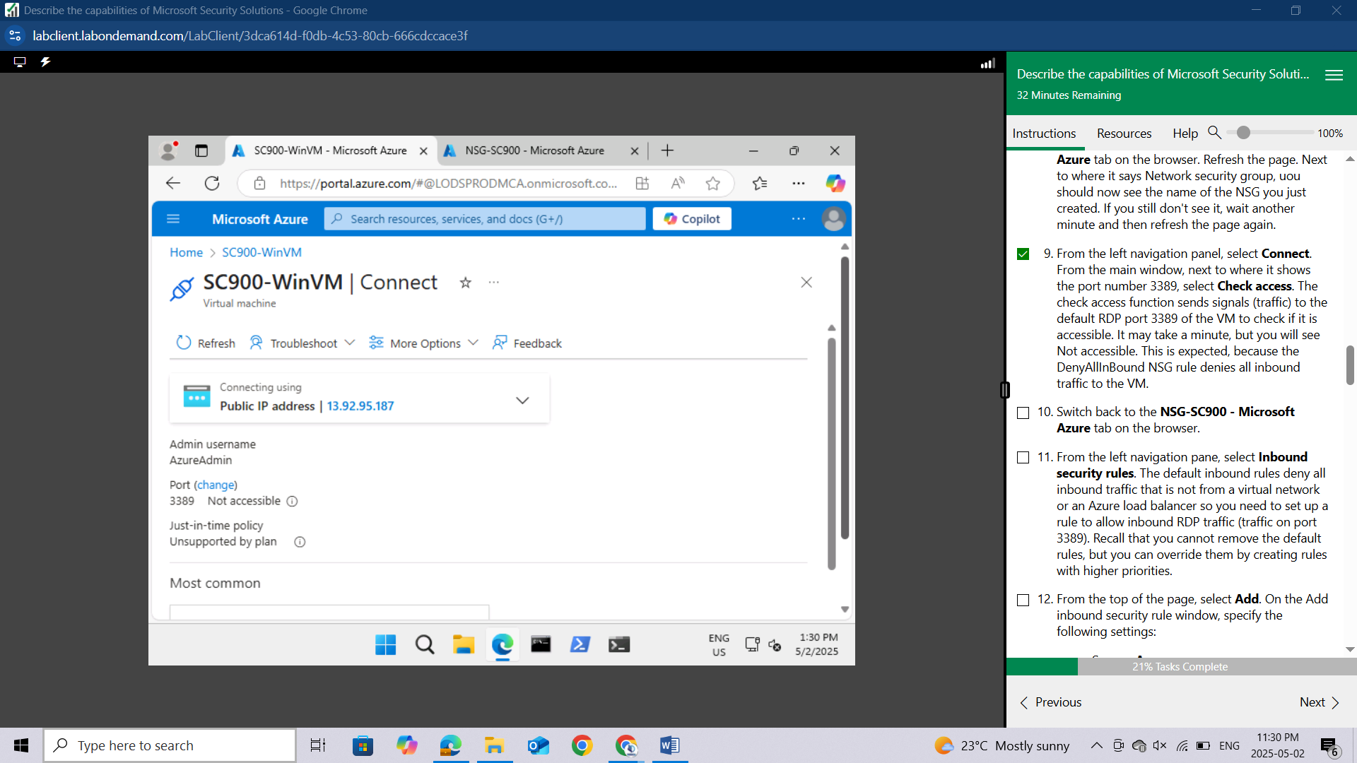

Switch back to the **NSG-SC900 -** Microsoft Azure tab on the browser.

From the left navigation pane, select **Inbound security rules**.

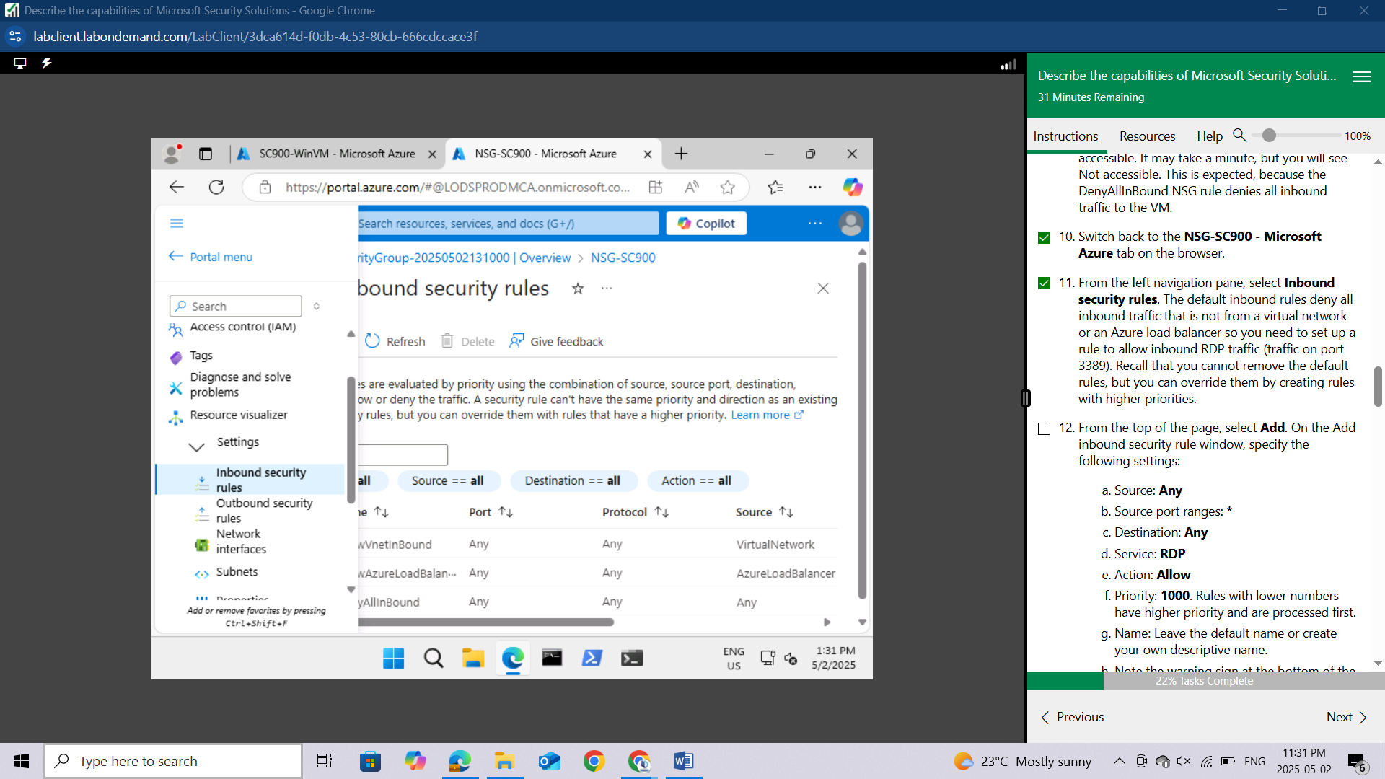

The default inbound rules deny all inbound traffic that is not from a virtual network or an Azure load balancer so you need to set up a rule to allow inbound RDP traffic (traffic on port 3389). Recall that you cannot remove the default rules, but you can override them by creating rules with higher priorities.

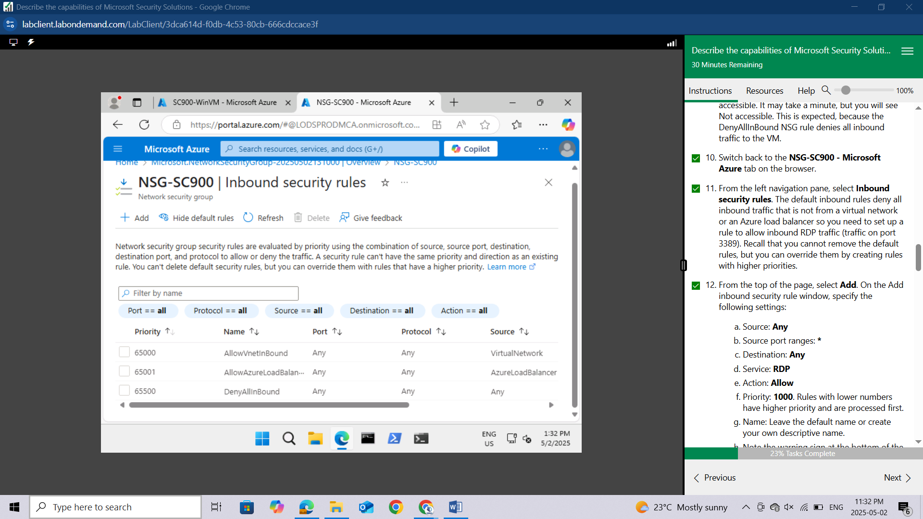

From the top of the page, select **Add**. On the Add inbound security rule window, specify the following settings:

Source: **Any**

Source port ranges: **\***

Destination: **Any**

Service: **RDP**

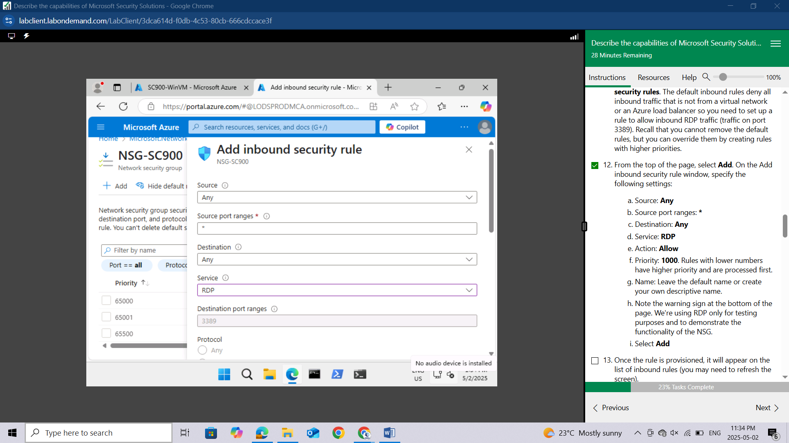

Action: **Allow**

Priority: **1000**. Rules with lower numbers have higher priority and are processed first.

Name: Leave the default name or create your own descriptive name.

Note the warning sign at the bottom of the page. We're using RDP only for testing purposes and to demonstrate the functionality of the NSG.

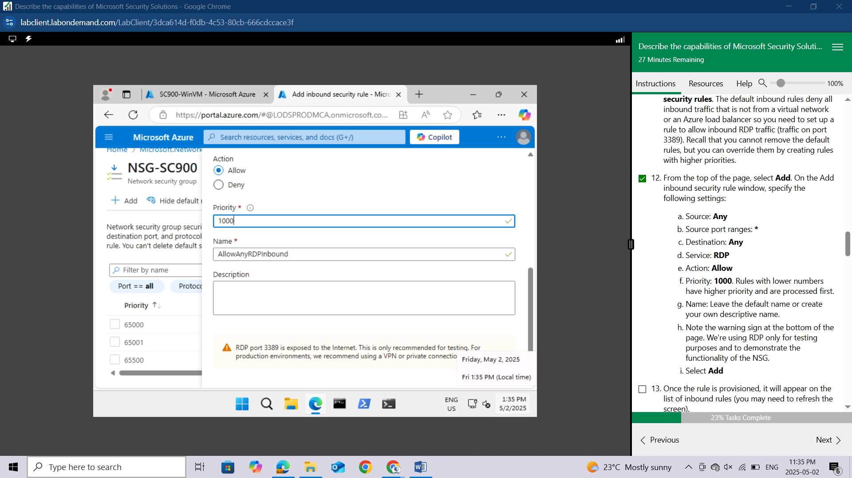

Select **Add**

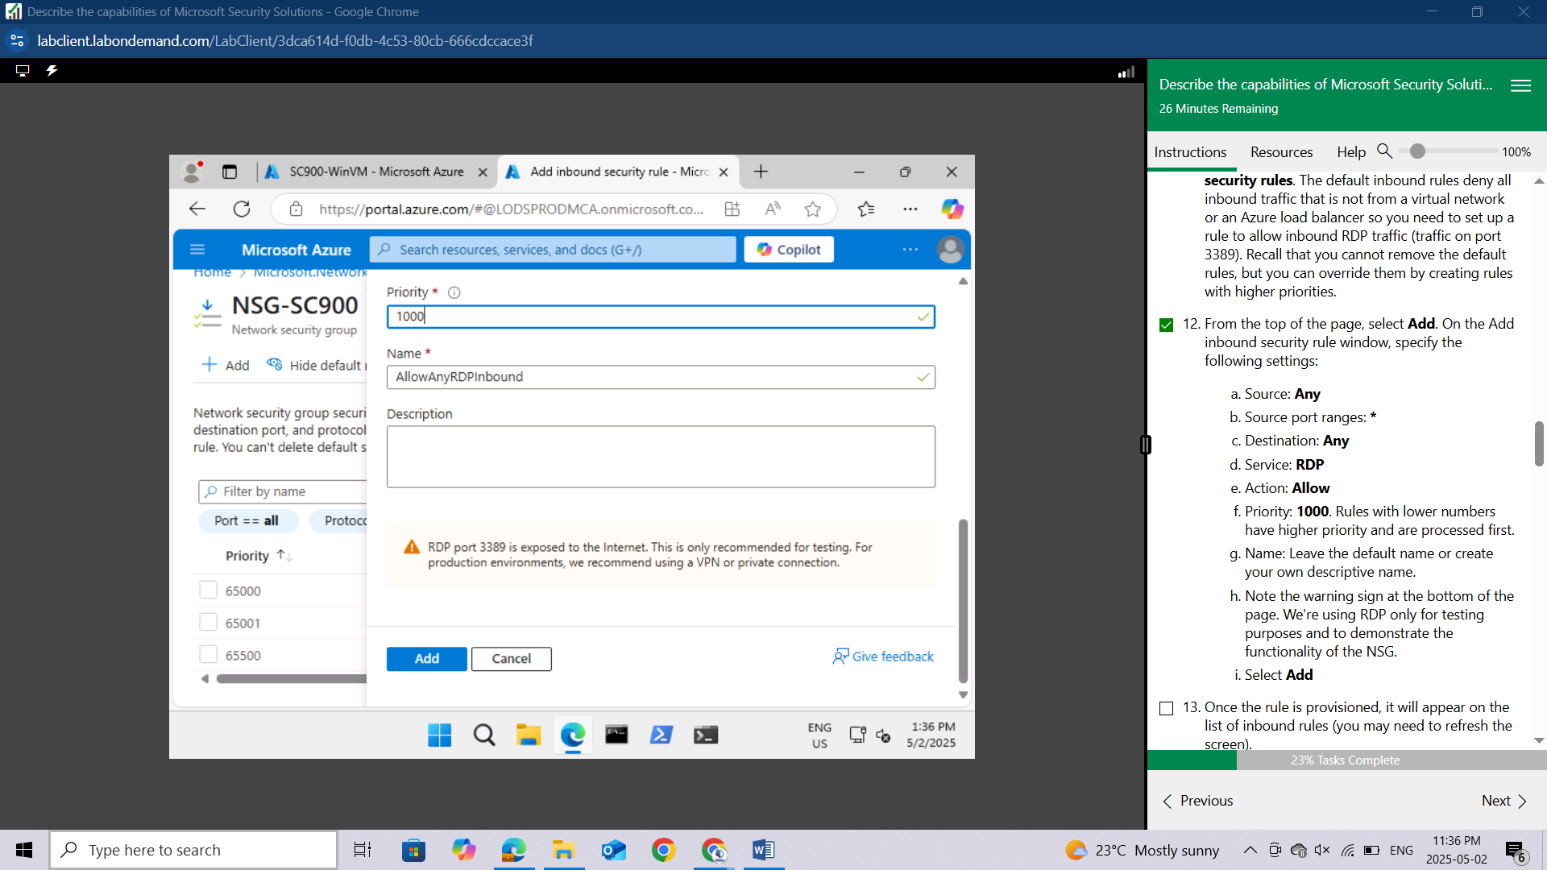

Once the rule is provisioned, it will appear on the list of inbound rules (you may need to refresh the screen).

Leave this browser tab open.

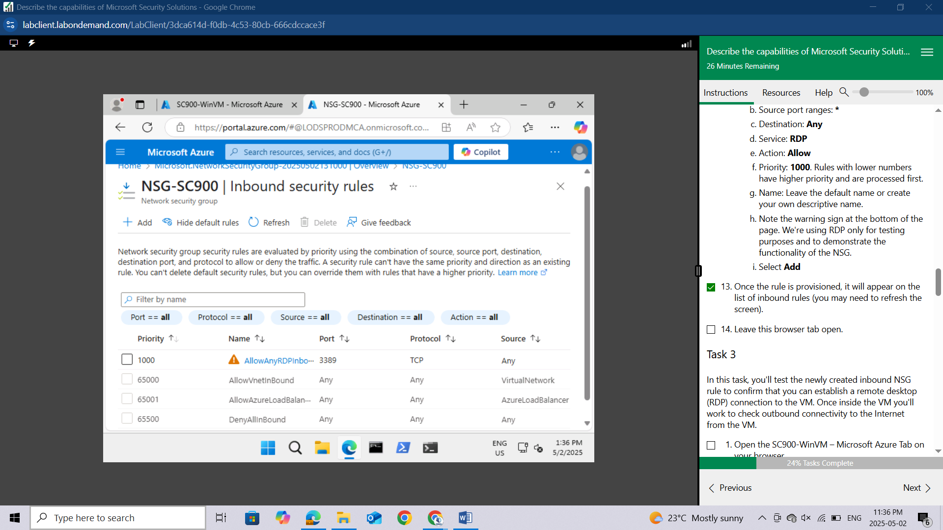

## Task 3

In this task, you'll test the newly created inbound NSG rule to confirm that you can establish a remote desktop (RDP) connection to the VM. Once inside the VM you'll work to check outbound connectivity to the Internet from the VM.

Open the **SC900-WinVM – Microsoft Azure** Tab on your browser.

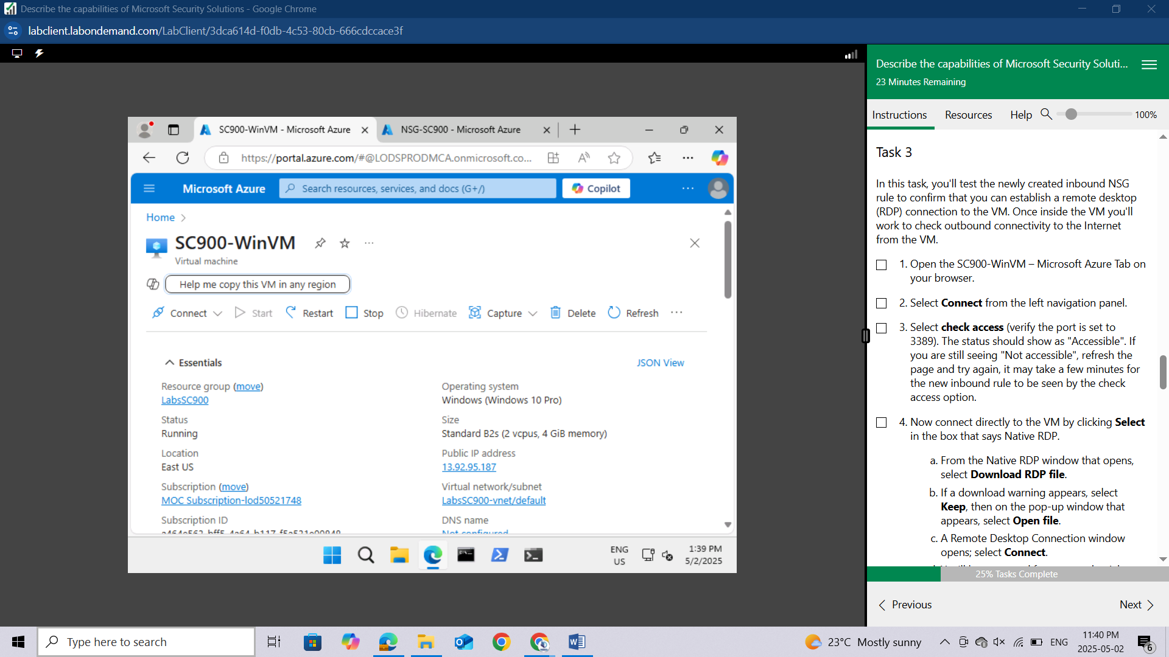

Select **Connect** from the left navigation panel.

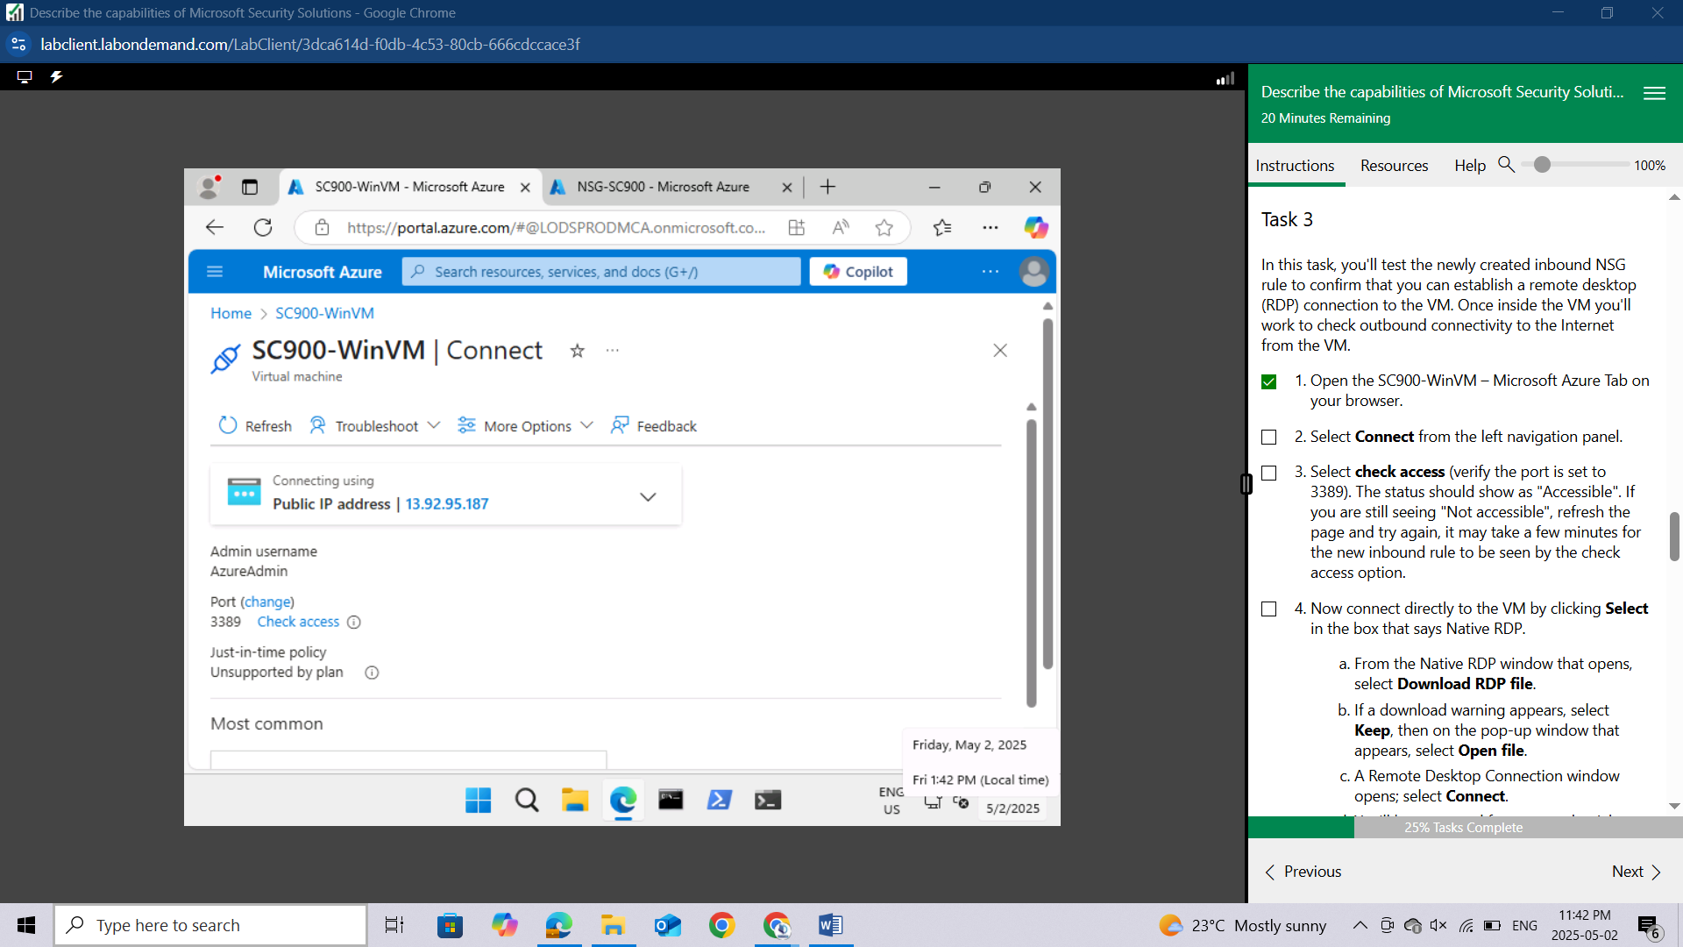

Select **check access** (verify the port is set to 3389). The status should show as "**Accessible**". If you are still seeing "Not accessible", refresh the page and try again, it may take a few minutes for the new inbound rule to be seen by the check access option.

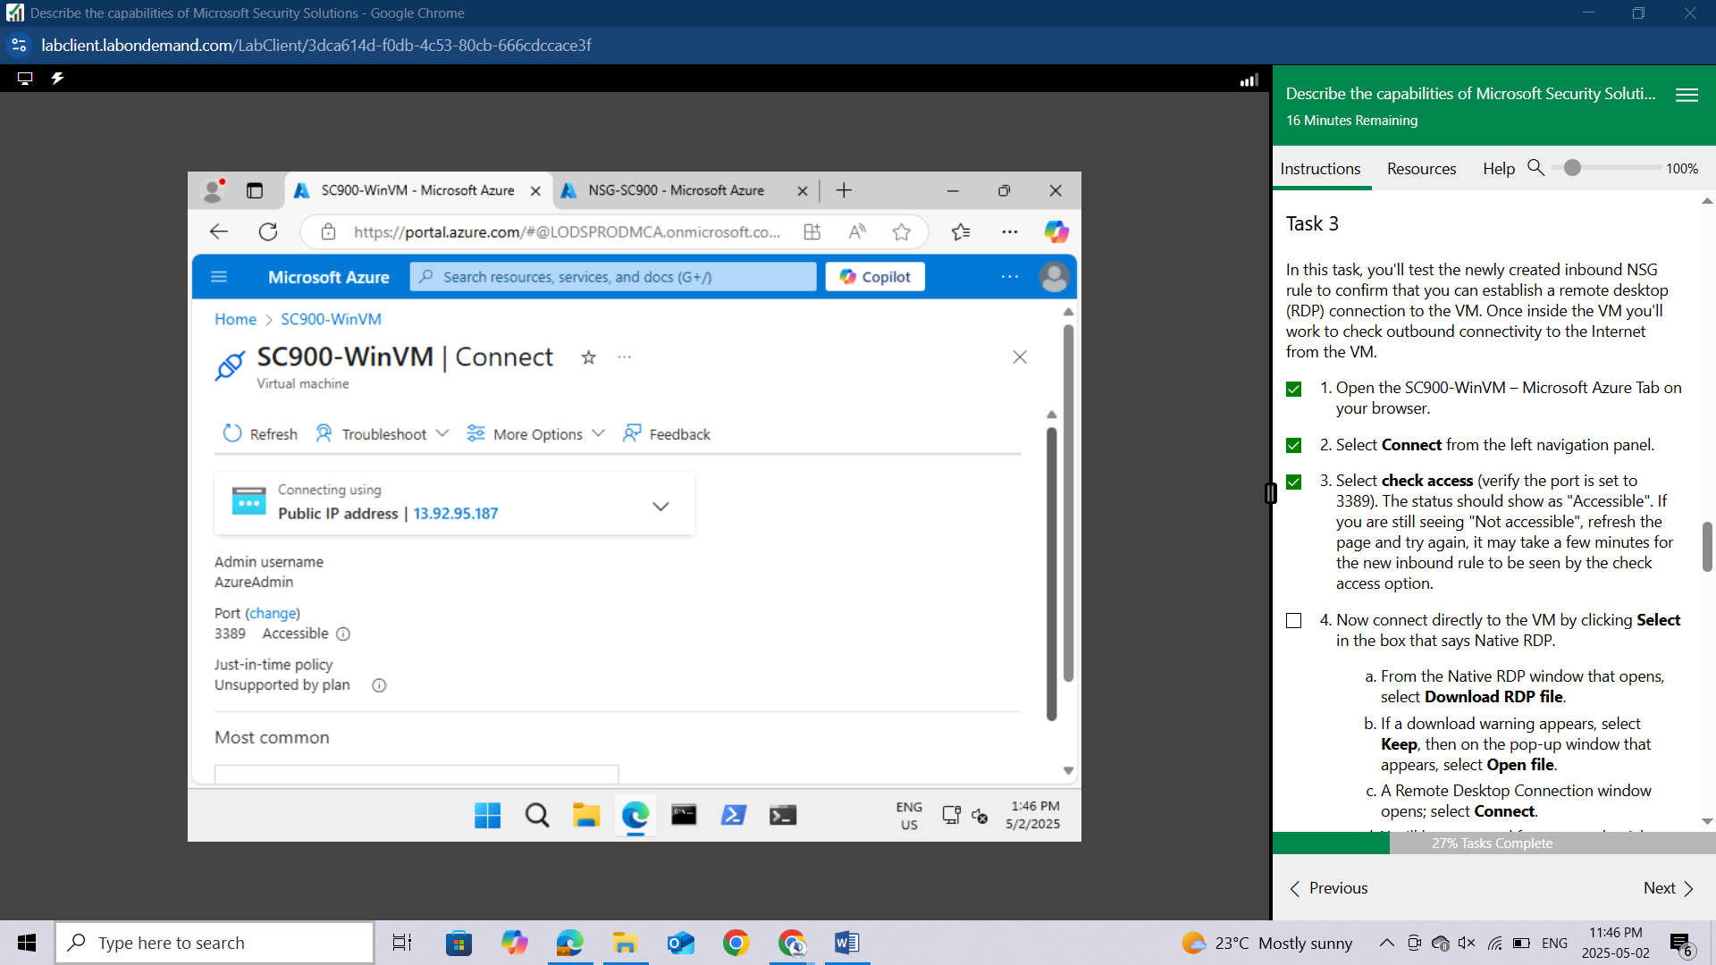

Now connect directly to the VM by clicking **Select** in the box that says Native RDP.

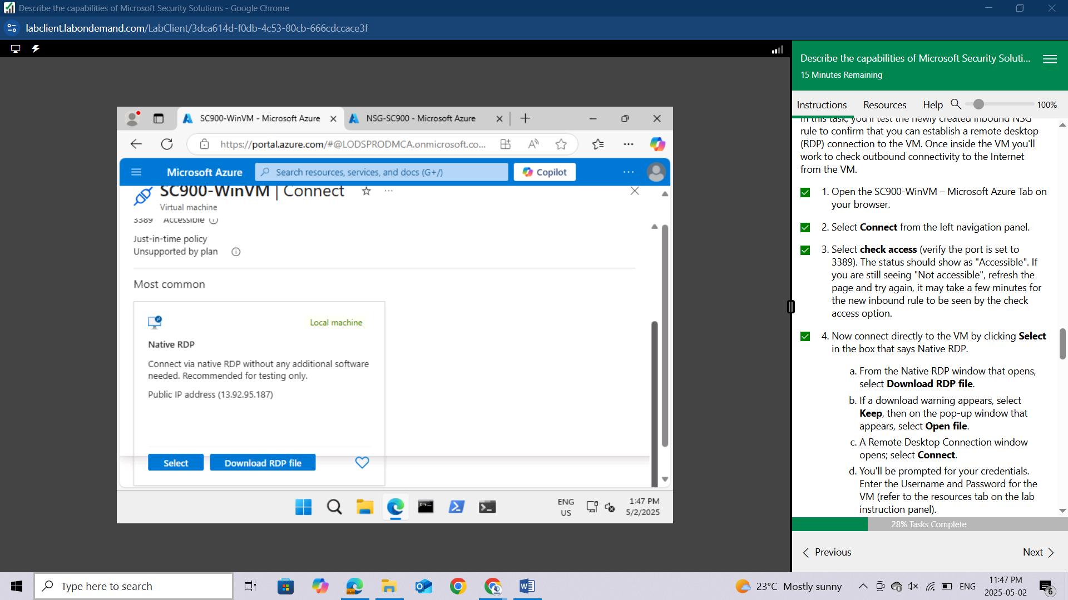

From the Native RDP window that opens, select **Download RDP file**.

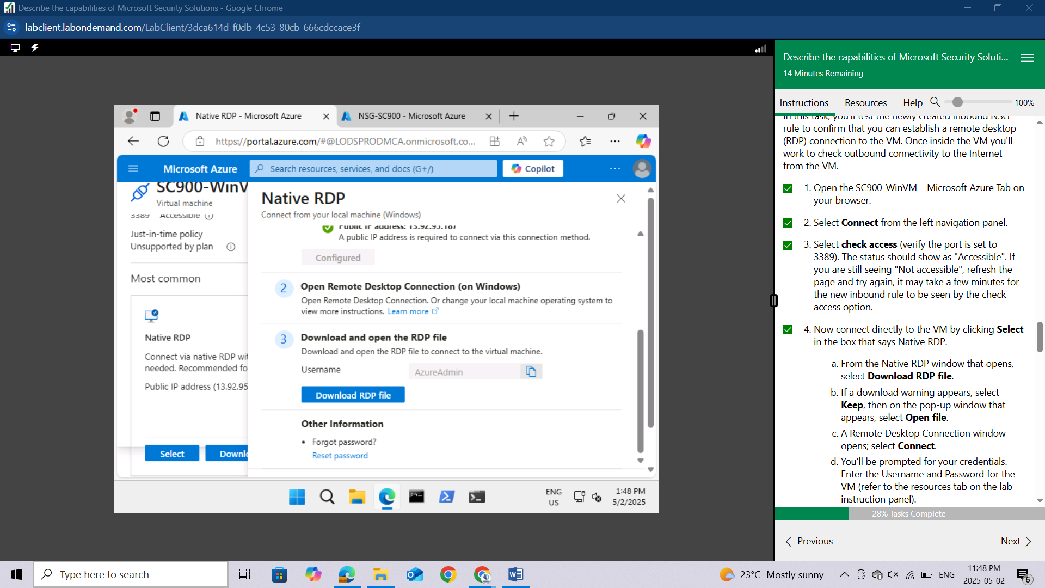

If a download warning appears, select **Keep**, then on the pop-up window that appears, select **Open** **file**.

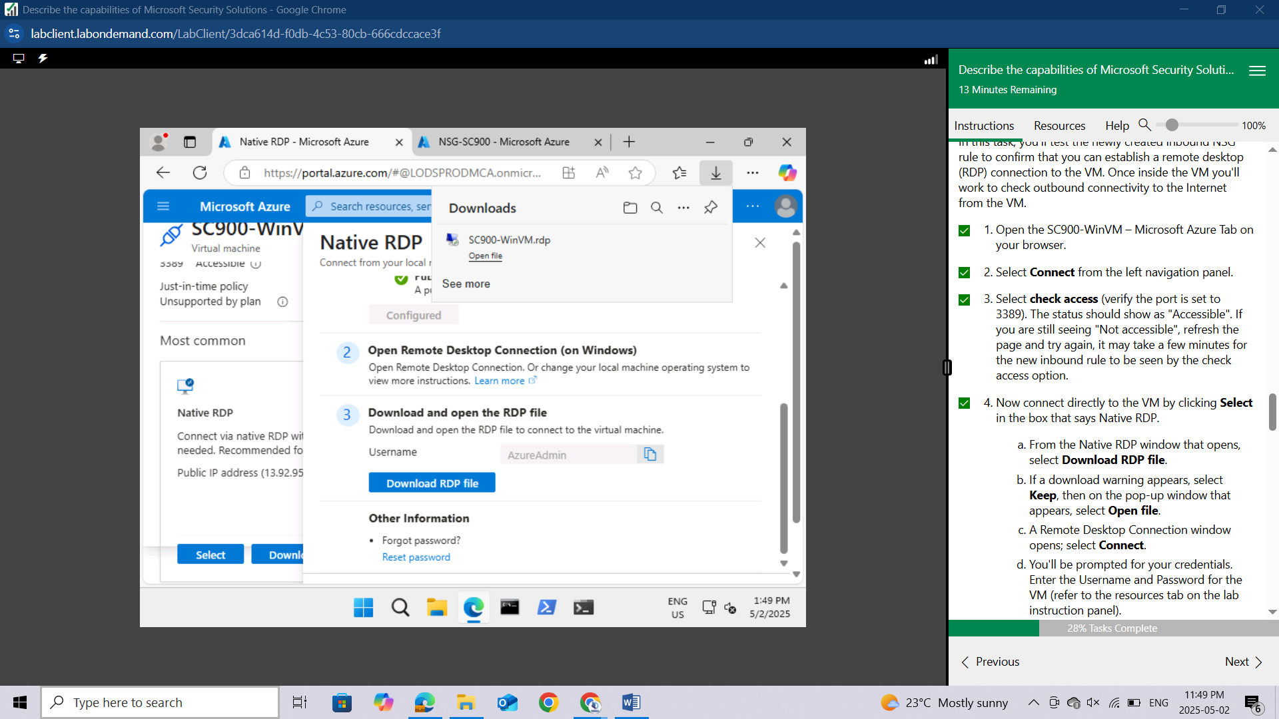

A Remote Desktop Connection window opens; select **Connect**.

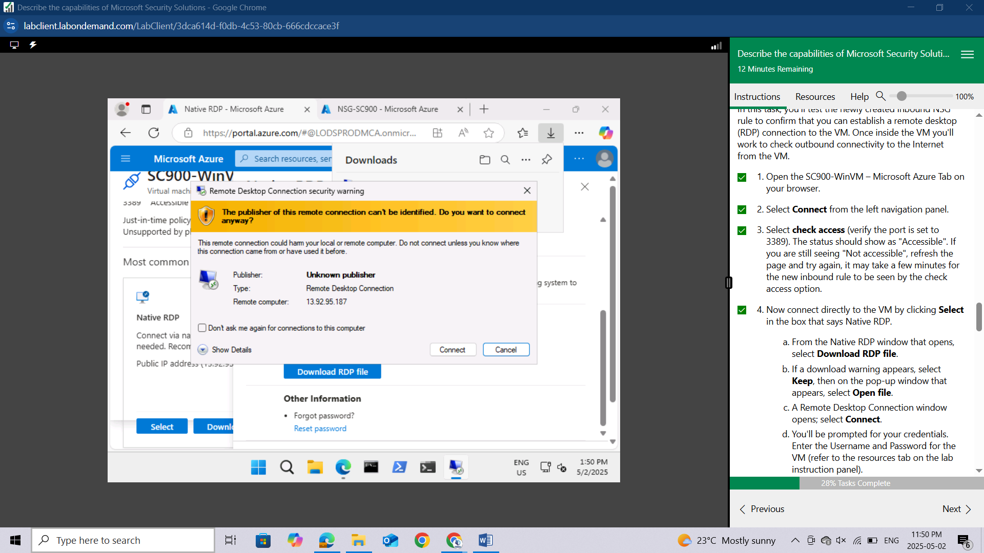

You'll be prompted for your credentials. Enter the Username and Password for the VM (refer to the resources tab on the lab instruction panel).

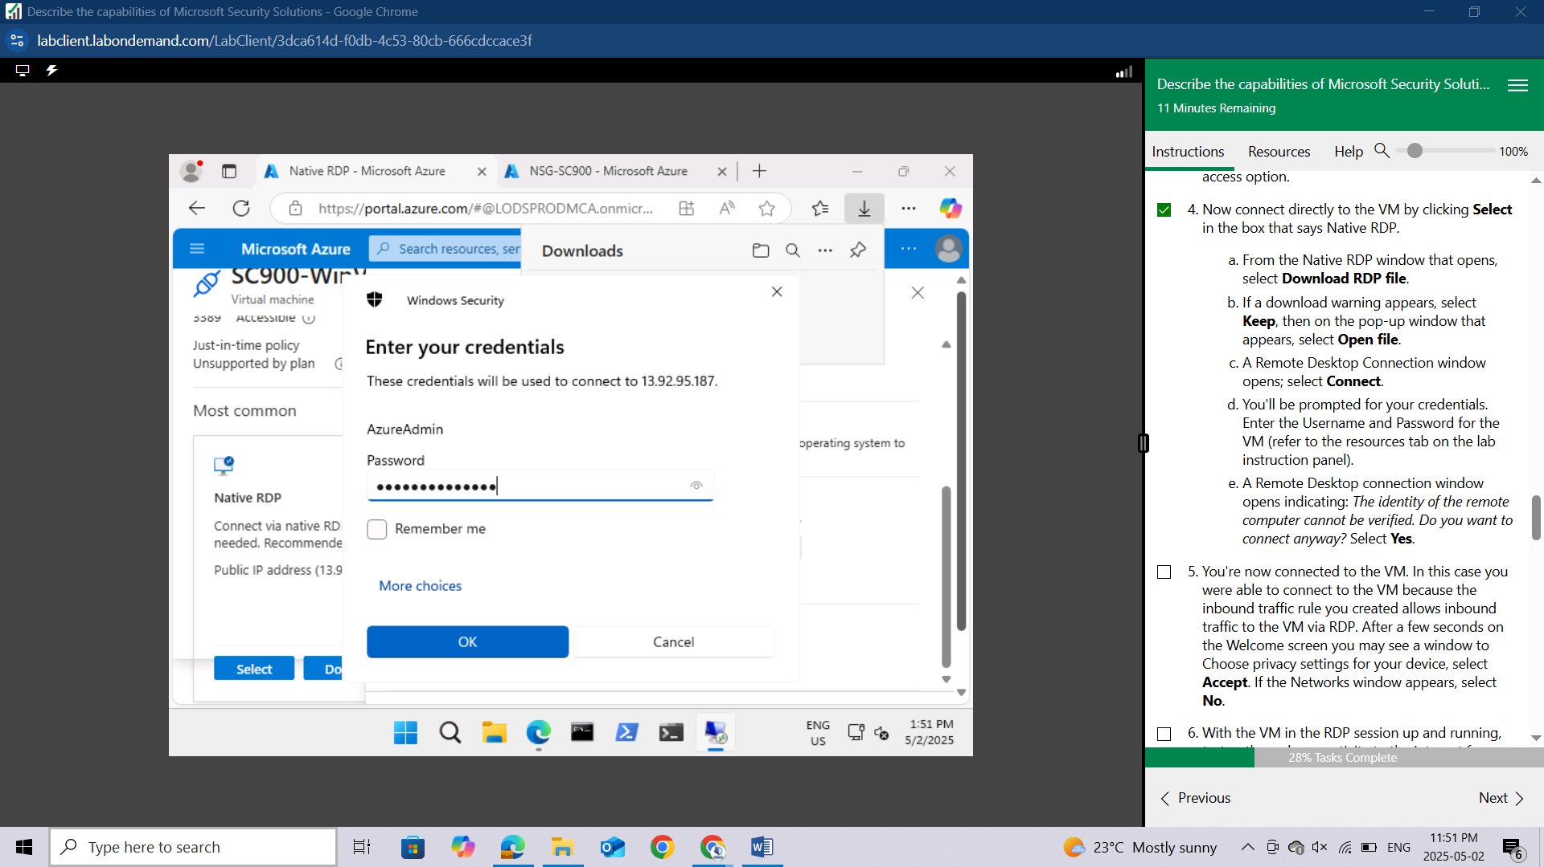

A Remote Desktop connection window opens indicating: The identity of the remote computer cannot be verified. Do you want to connect anyway? Select **Yes**.

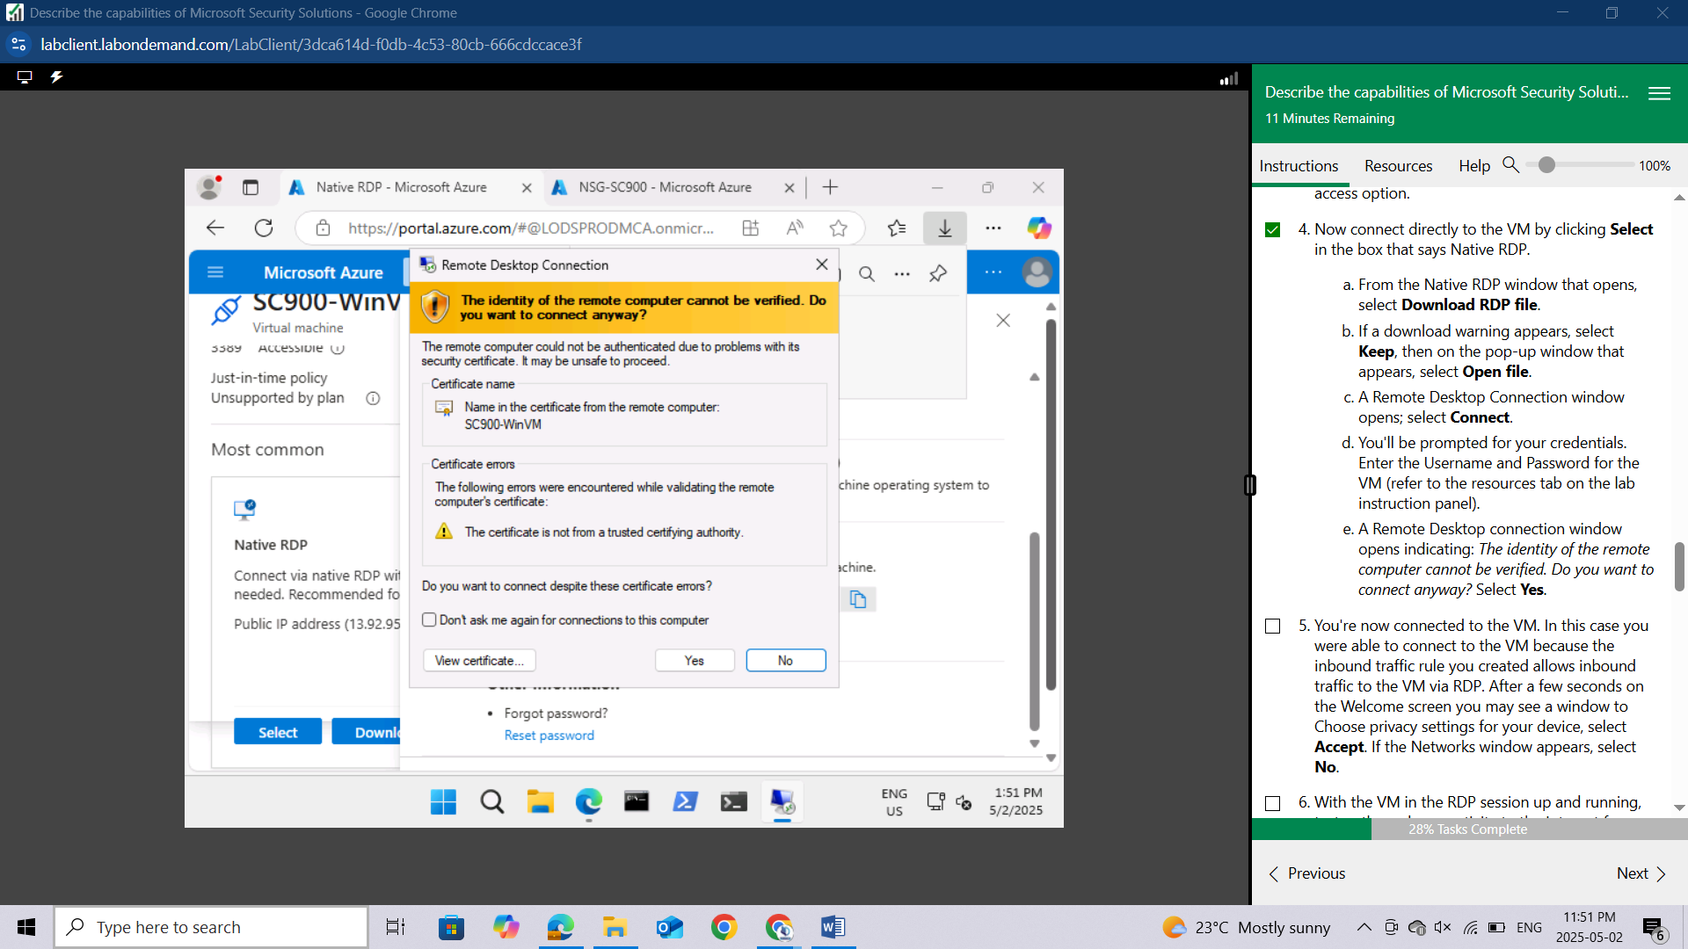

You're now connected to the VM. In this case you were able to connect to the VM because the inbound traffic rule you created allows inbound traffic to the VM via RDP. After a few seconds on the Welcome screen you may see a window to Choose privacy settings for your device, select **Accept**.

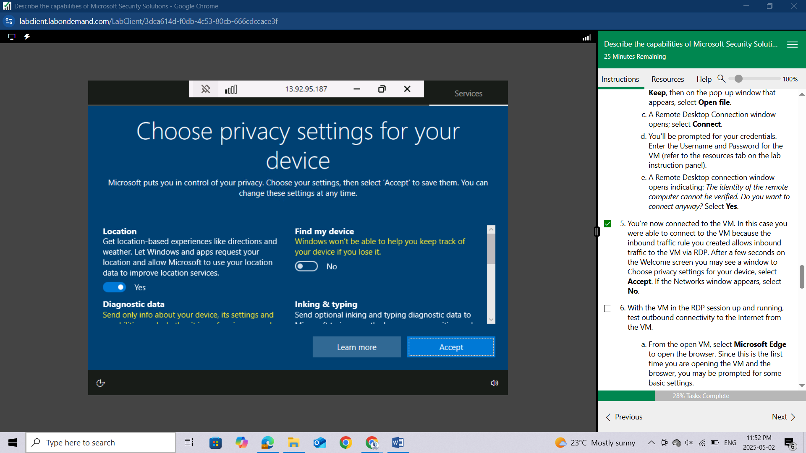

If the Networks window appears, select **No**.

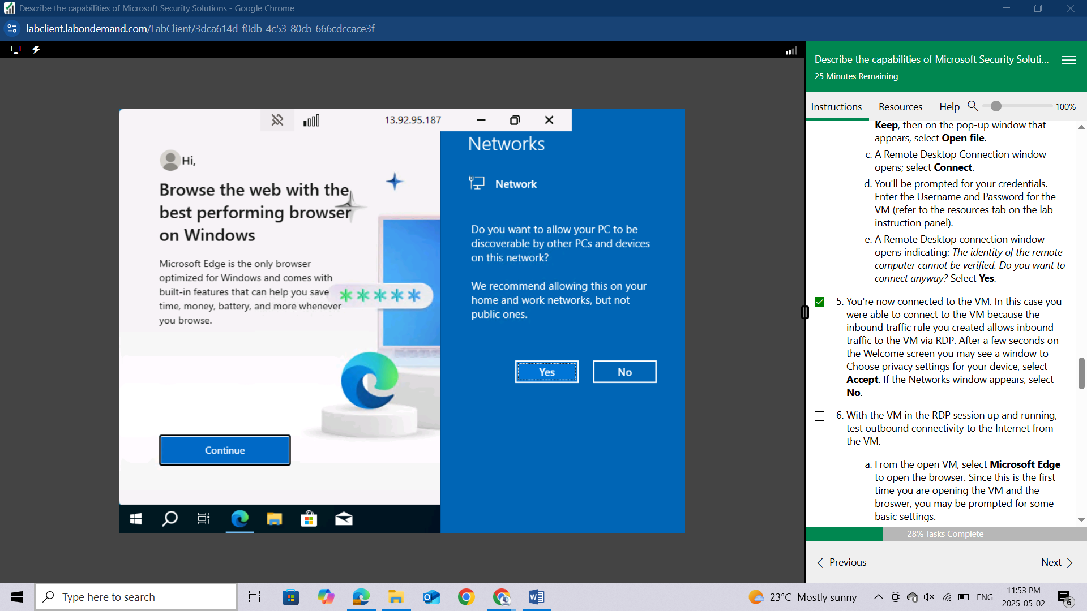

With the VM in the RDP session up and running, test outbound connectivity to the Internet from the VM.

From the open VM, select Microsoft Edge to open the browser. Since this is the first time you are opening the VM and the broswer, you may be prompted for some basic settings.

You may be prompted to choose privacy settings for your device. Leave the default and select Accept.

A side panel for Networks, may display. Select **No**.

A window may appear that says "Browse the web with the best performing browser on Windows," select **Continue**, select **Start without your data**, select **Confirm and continue**, select **Continue without this data**, then finally select **Confirm and start browsing**.

Enter [**www.bing.com**](http://www.bing.com) in the browser address bar and confirm you're able to connect to the search engine.

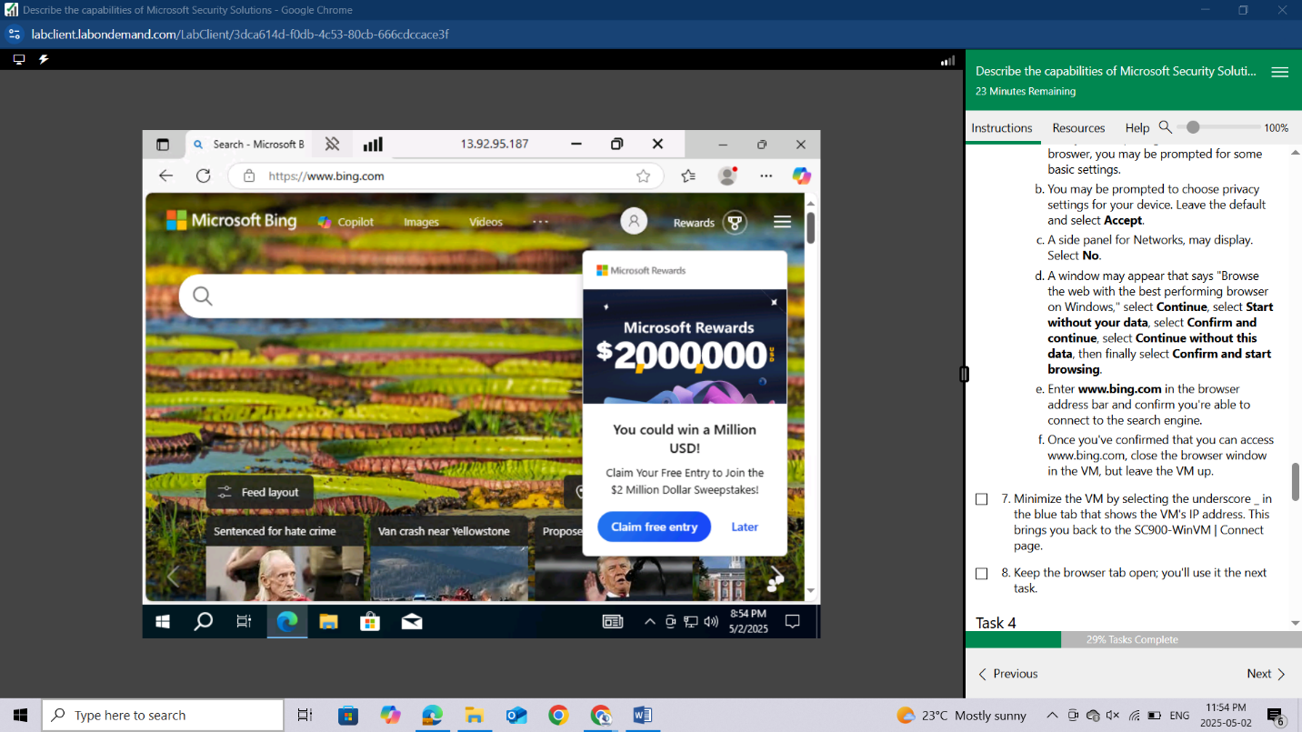

Once you've confirmed that you can access [www.bing.com](http://www.bing.com) , close the browser window in the VM, but leave the VM up.

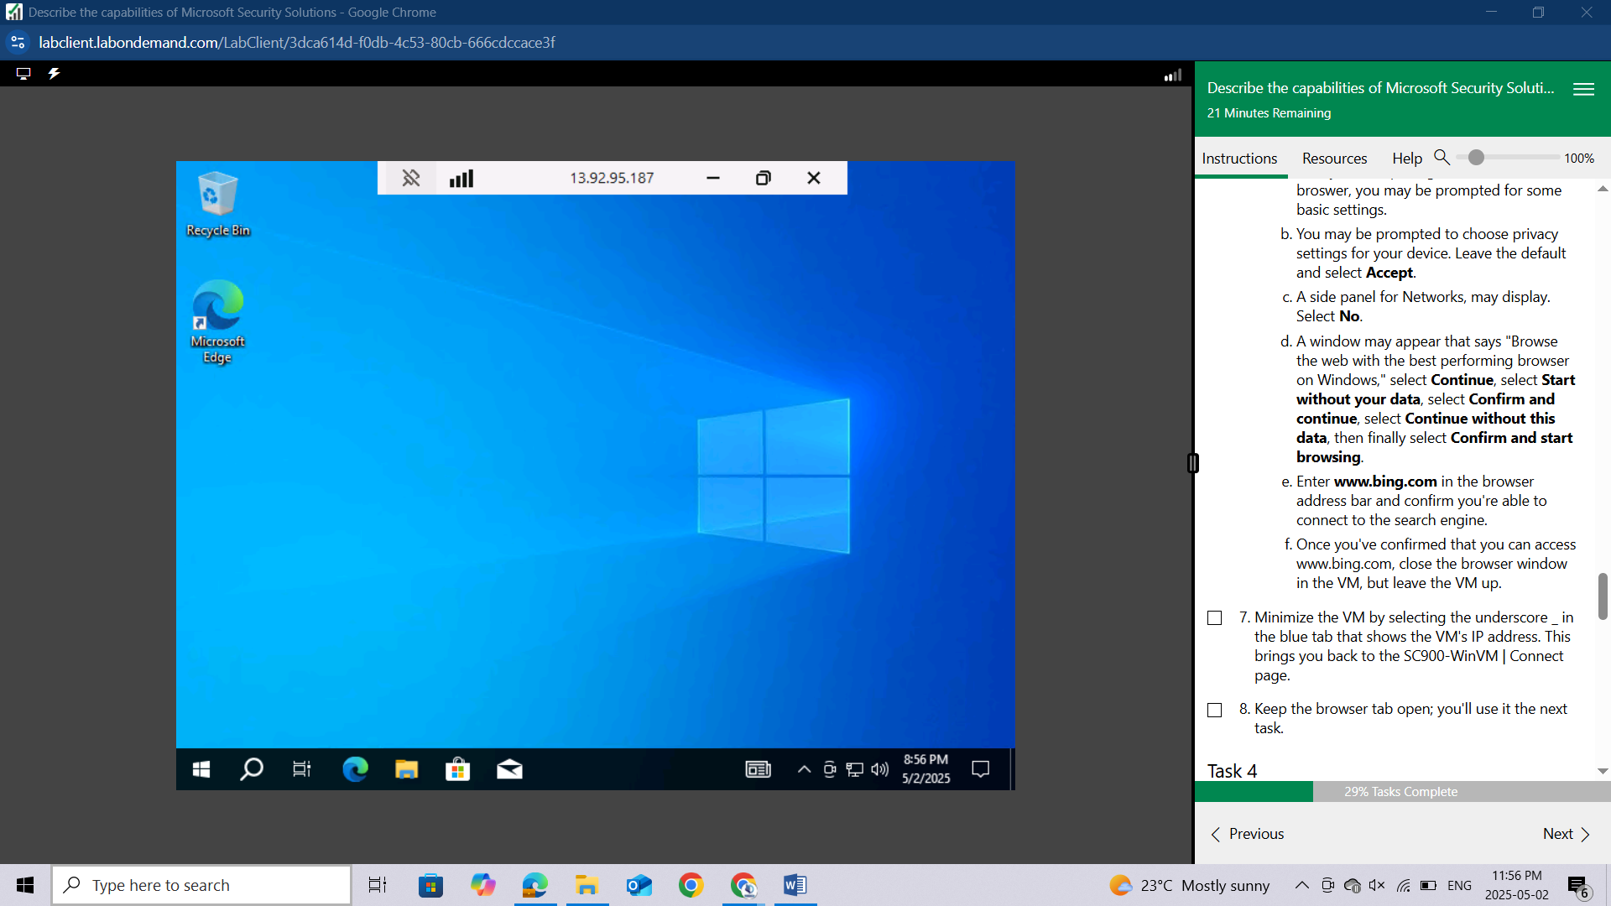

Minimize the VM by selecting the underscore _ in the blue tab that shows the VM's IP address. This brings you back to the SC900-WinVM | Connect page.

Keep the browser tab open; you'll use it the next task.

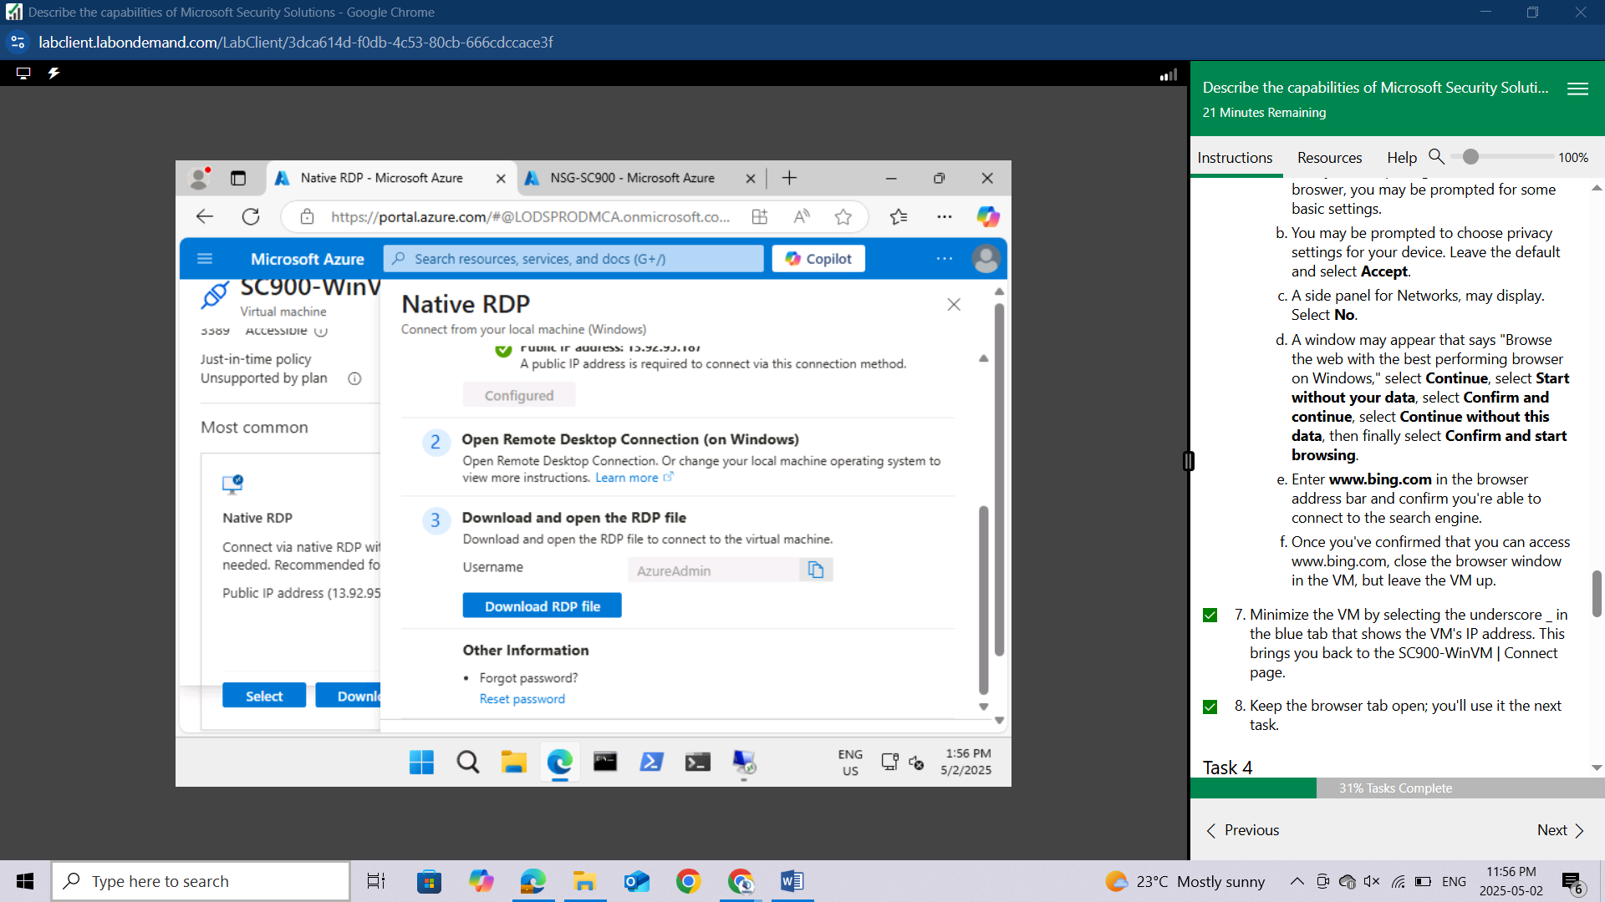

## Task 4

In the previous task you confirmed that you could establish an RDP connection to the VM. Once in the VM you also confirmed that you could establish an outbound connection to the Internet. The outbound Internet traffic was allowed because the default outbound rules for NSG allow outbound Internet traffic. In this task, you'll go through the process of creating a custom outbound rule to block outgoing Internet traffic and test that rule.

You should be on the SC900-WinVM | Connect page. From the left navigation panel, select **Networking.** If you previously closed the browser tab, select the blue search bar on the top of the page and select **Virtual machines**, then select the **VM, SC900-WinVM**, then select **Networking.**

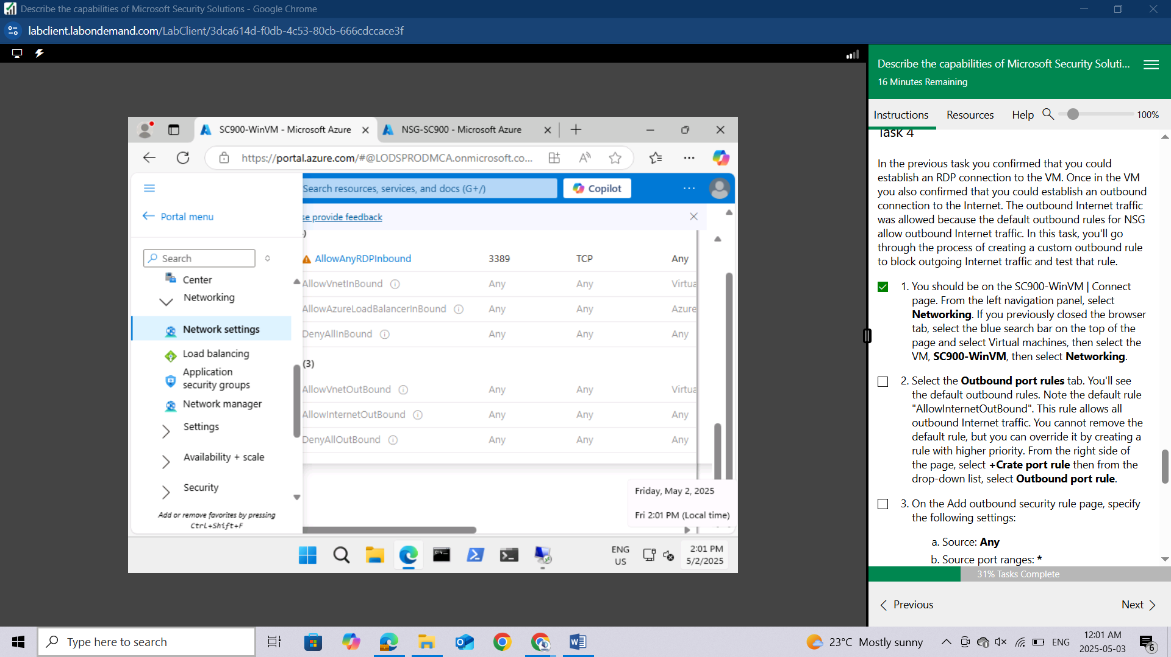

Select the Outbound port rules tab. You'll see the default outbound rules. Note the default rule "**AllowInternetOutBound**". This rule allows all outbound Internet traffic. You cannot remove the default rule, but you can override it by creating a rule with higher priority. From the right side of the page, select **+Crate port rule** then from the drop-down list, select **Outbound port rule**.

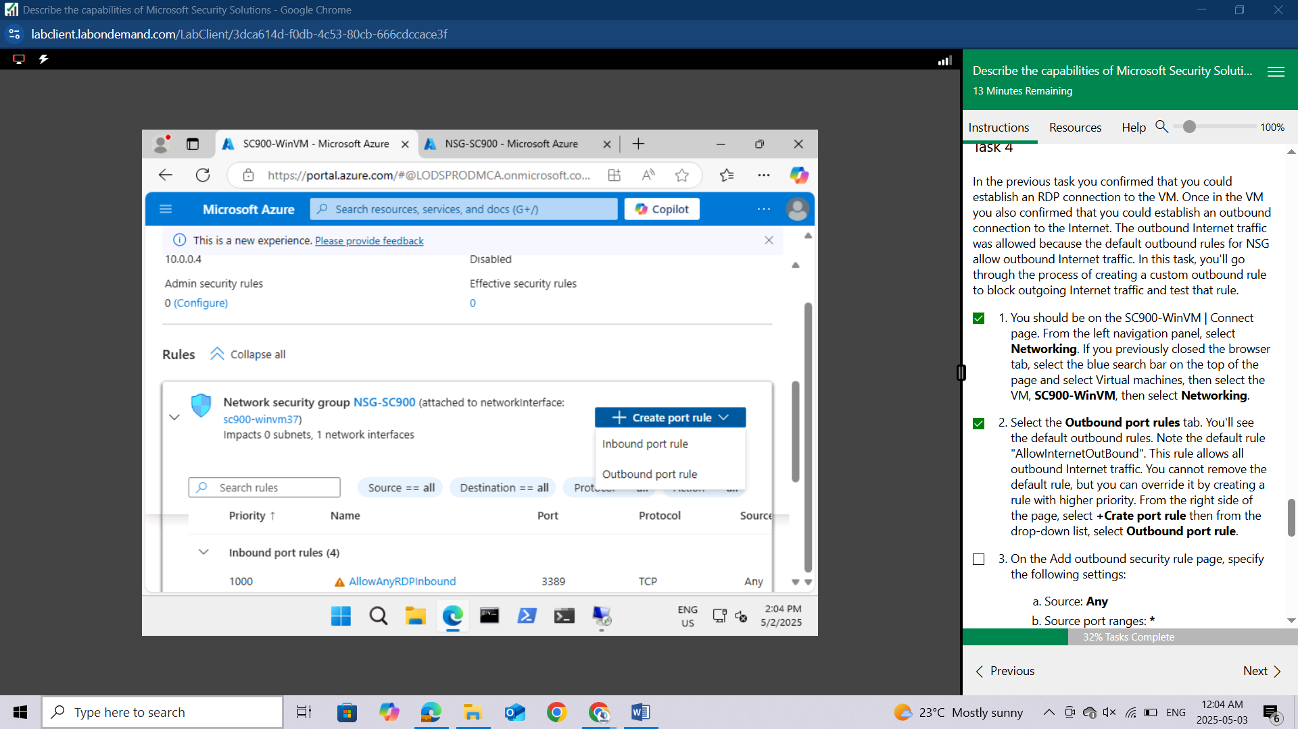

On the Add outbound security rule page, specify the following settings:

Source: **Any**

Source port ranges: **\***

Destination**: Service Tag**

Destination service tag: **Internet**

Service: **Custom** (leave the default)

Destination port ranges: **\*** (be sure to put an asterisk in the destination port ranges field)

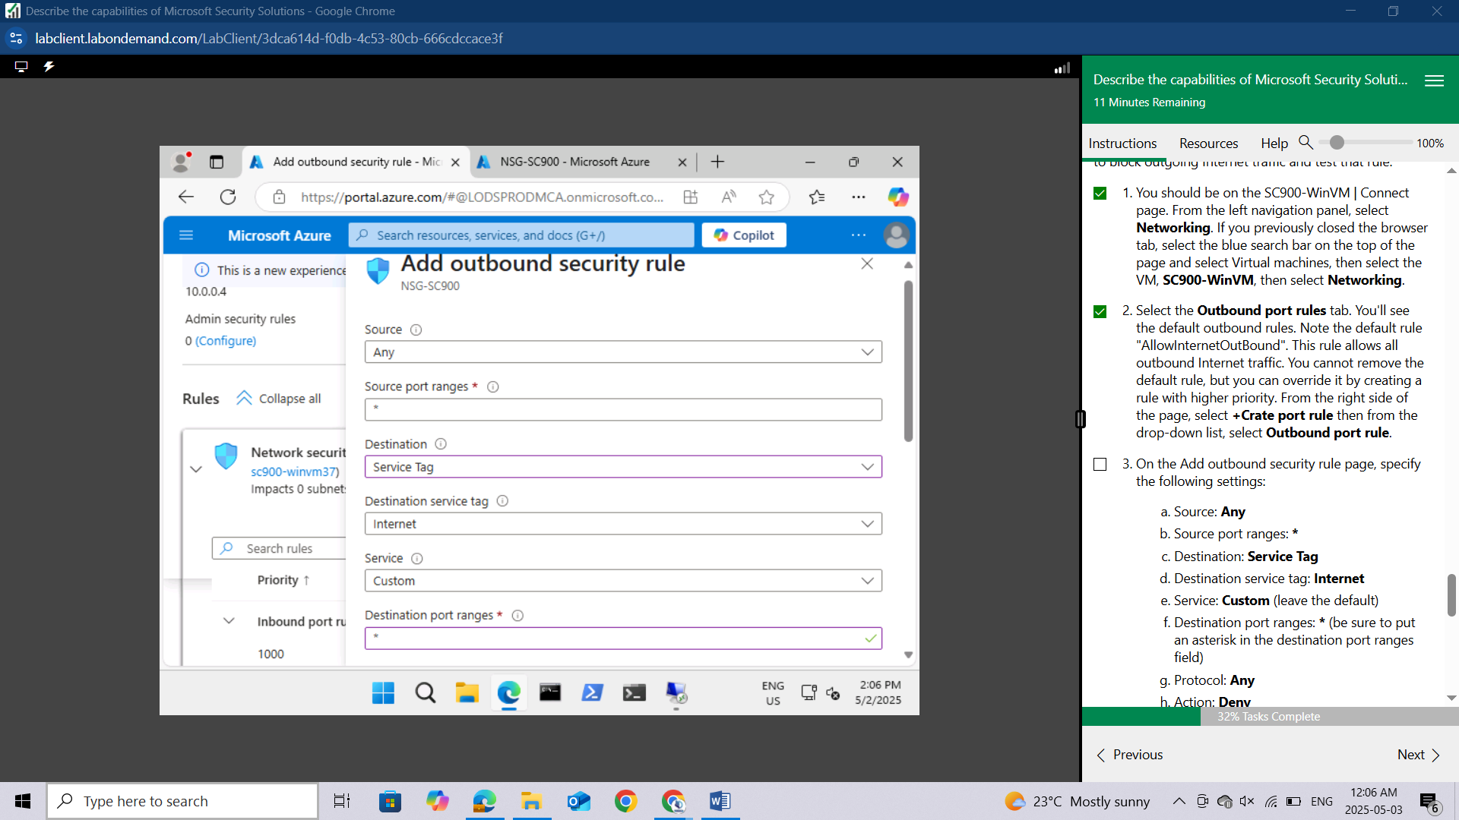

Protocol: **Any**

Action: **Deny**

Priority: **1000**

Name: Leave the default name or create your own descriptive name.

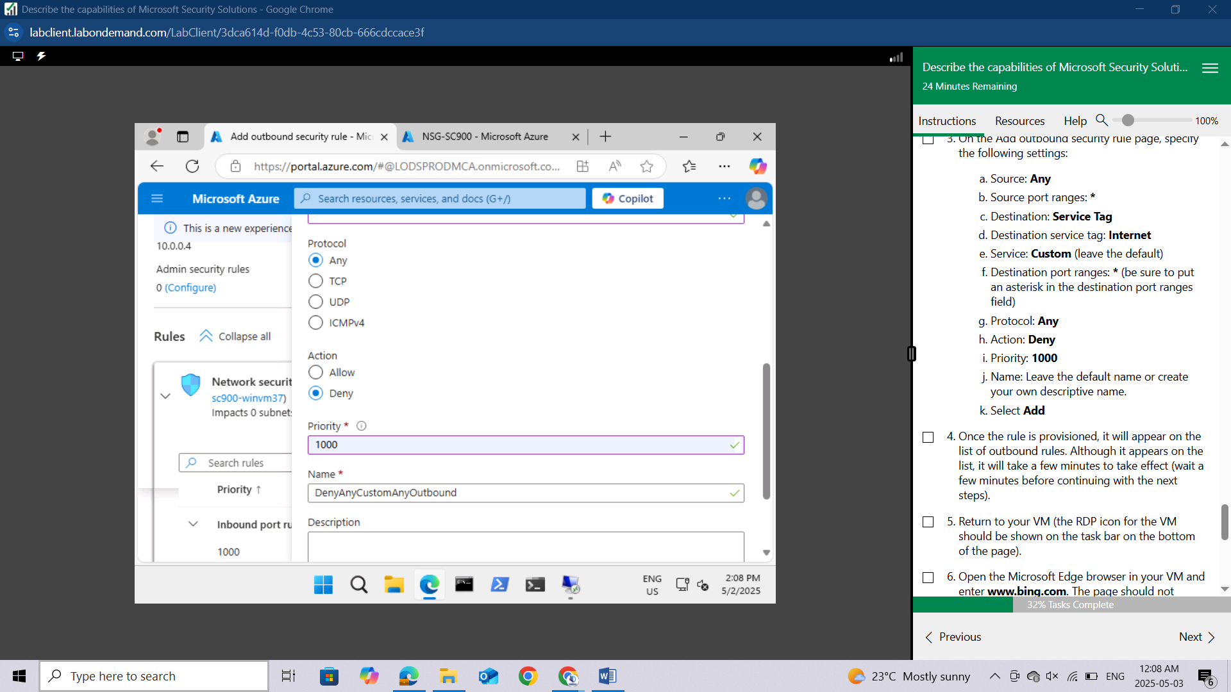

Select **Add**

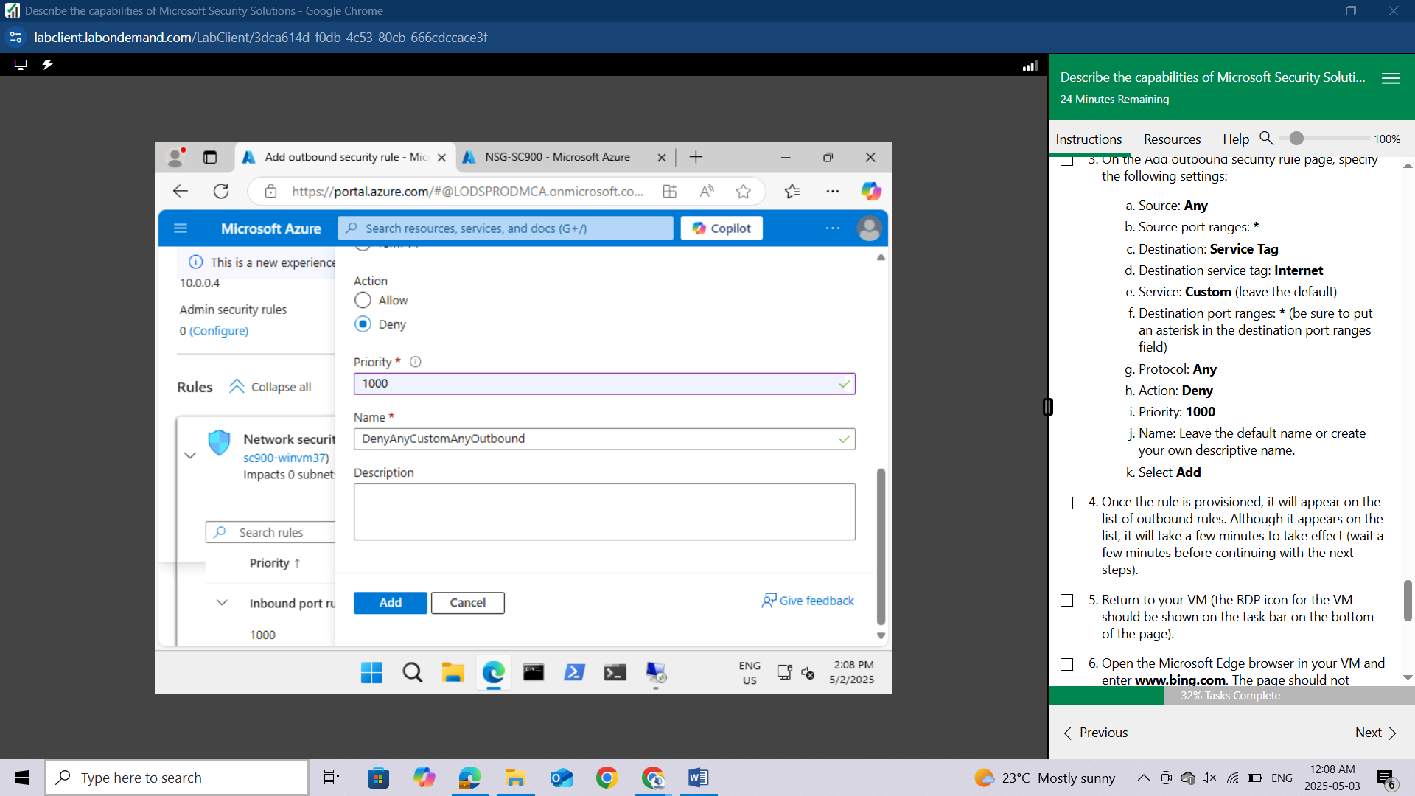

Once the rule is provisioned, it will appear on the list of outbound rules. Although it appears on the list, it will take a few minutes to take effect (wait a few minutes before continuing with the next steps).

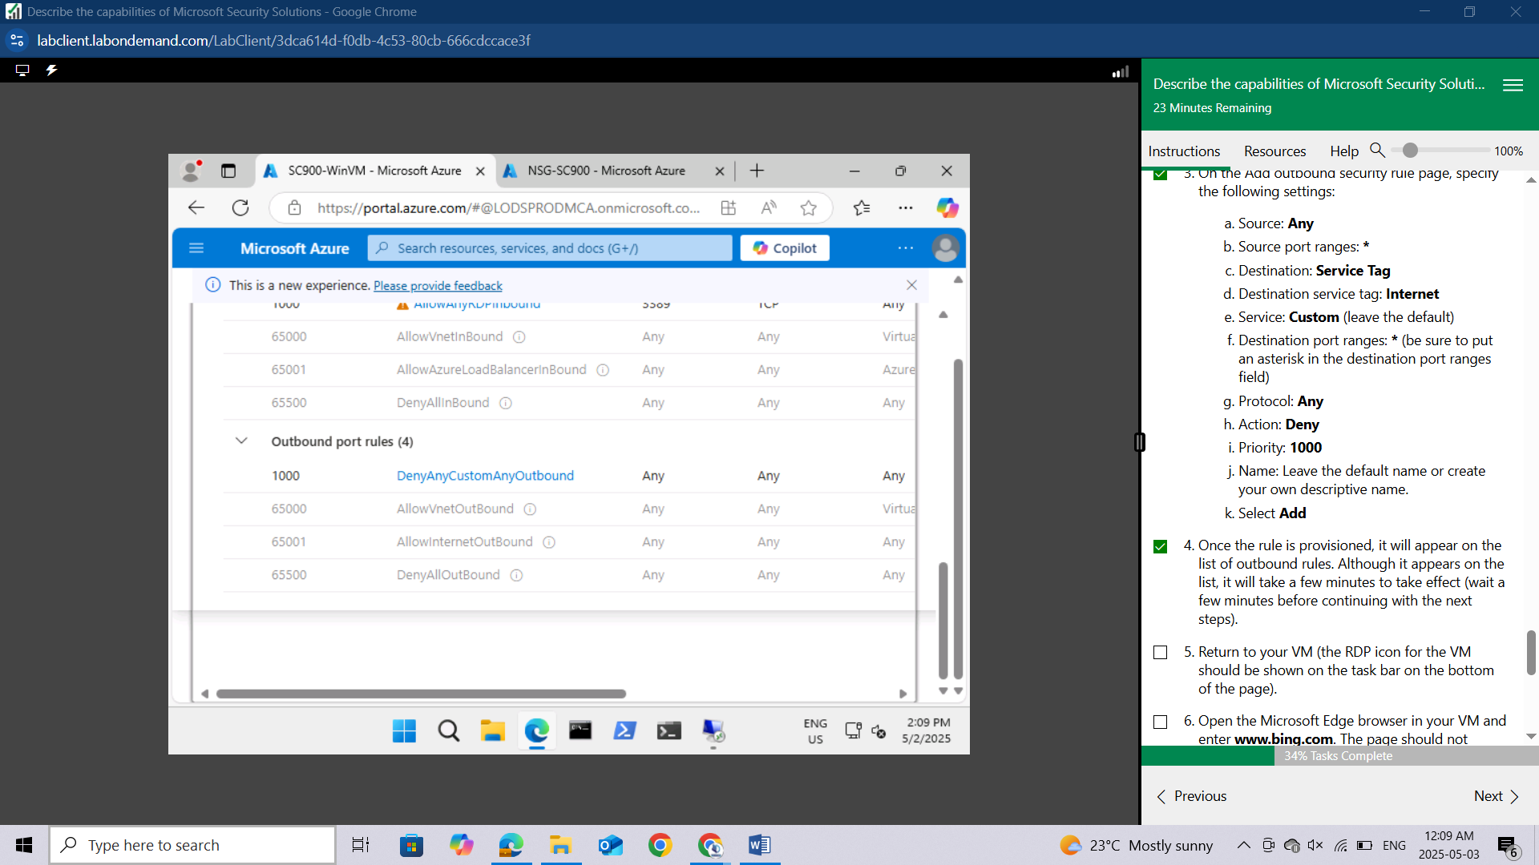

Return to your VM (the RDP icon for the VM should be shown on the task bar on the bottom of the page).

Open the Microsoft Edge browser in your VM and enter www.bing.com. The page should not display. If you're able to connect to the internet and you verified that all the parameters for the outbound rule were properly set, it's likely because it takes a few minutes for the rule to take effect. Close the browser, wait a few minutes and try again. Azure subscriptions in the lab environment may experience longer than normal delays.

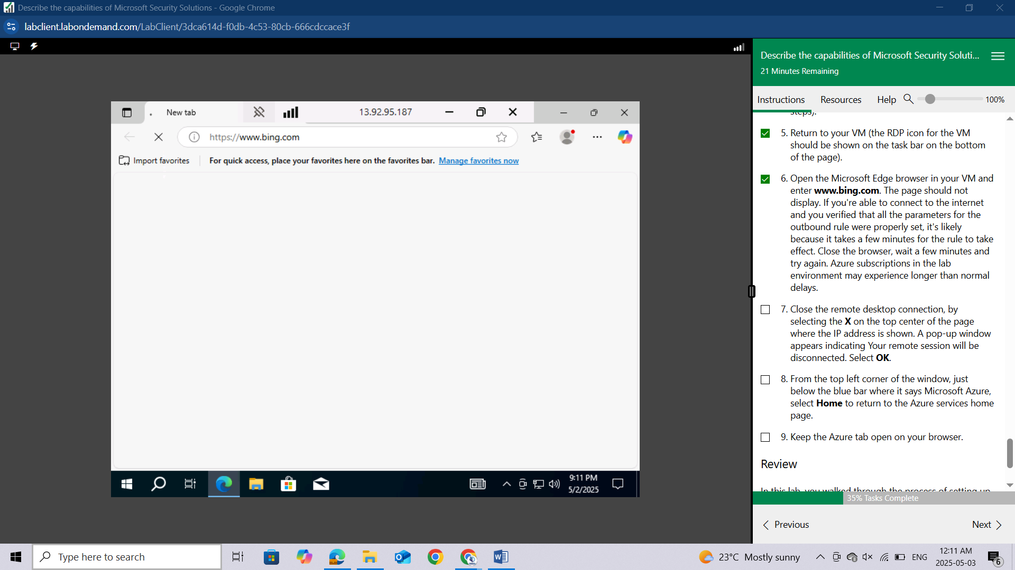

Close the remote desktop connection, by selecting the **X** on the top center of the page where the IP address is shown. A pop-up window appears indicating Your remote session will be disconnected. Select **OK**.

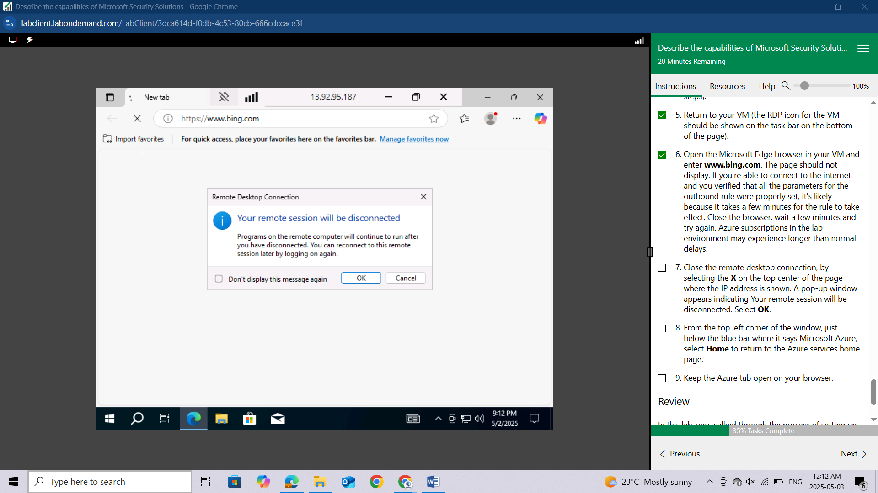

From the top left corner of the window, just below the blue bar where it says Microsoft Azure, select **Home** to return to the Azure services home page.

Keep the Azure tab open on your browser.

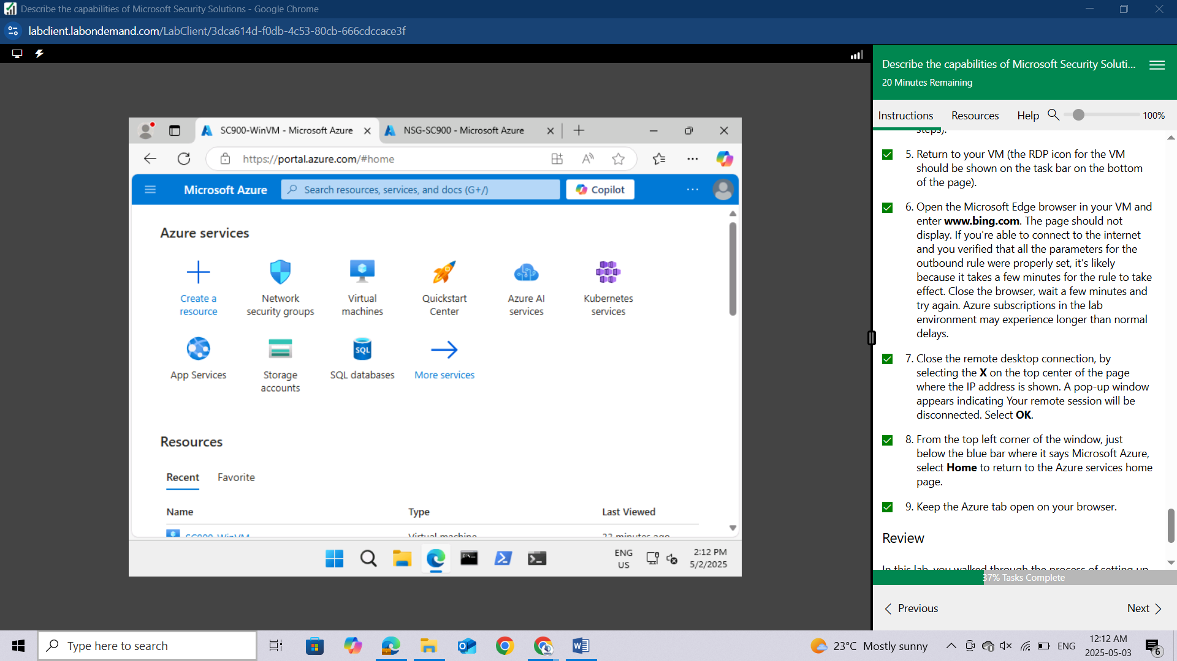

## Review

In this lab, you walked through the process of setting up a network security group (NSG), associating that NSG to the network interface of a virtual machine, and adding new rules to the NSG to allow inbound RDP traffic and to block outbound Internet traffic.